Standard Operating Procedure (SOP):
Precheck Application (Godrej Aerospace)

1. Introduction
The Precheck application (Godrej Aerospace, Version 8.4) is a web-based quality and inventory checkpoint system. It digitizes the process of verifying that the correct physical components have been gathered for an assembly — by scanning or entering each part's QR code — before the parts are stored, issued, or consumed further in production.
The application is used by four types of users, called roles: Admin, QC, Store, and Planner. Each role sees a different set of menu items and buttons depending on what the Admin has granted them access to (see the Role Management section).
Before day-to-day work such as uploading Production Orders or performing a Precheck can begin, certain foundational (“master”) data must be set up by an Admin — Units, Stages, Shapes, Production Series, Components, Roles, and Users. This SOP therefore covers that setup first, followed by the day-to-day operational screens in the order they normally appear in the left-hand navigation menu.

2. Getting Started – Login & Account

Login Page
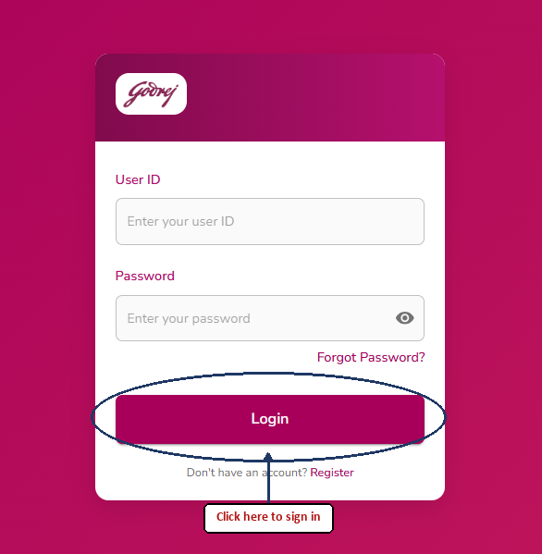
Purpose: Lets an existing user sign in to the Precheck system using their User ID and Password.
Buttons and what they do:
- Login button: Checks the User ID and Password. If both are correct, you are taken to the Dashboard page. If either field is empty or wrong, an error message appears above the button and you stay on the Login page.
- "Forgot Password?" link: Takes you to the Reset Password page if you do not remember your password.
- "Register" link (at the bottom): Takes you to the New User Registration page if you do not have an account yet.
Important notes: Pressing Enter after typing the User ID automatically moves the cursor to the Password box.

New User Registration Page
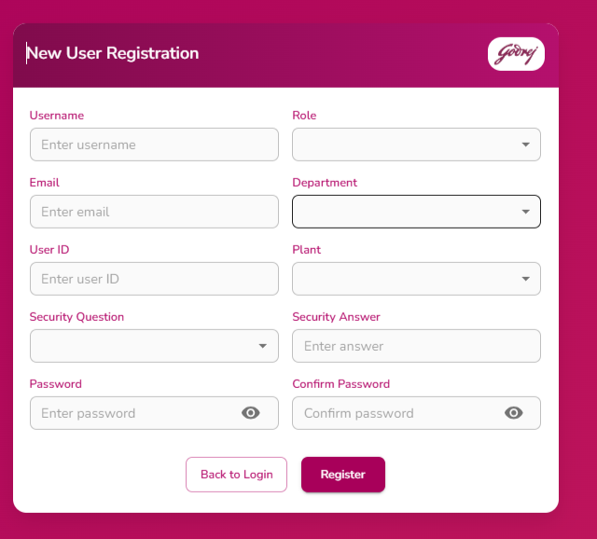
Purpose: Lets a new employee create a login account for the Precheck system.
Buttons and what they do:
- Register button: Only becomes active once all required fields are filled in correctly. When clicked, it creates the new account, shows a "Registration successful" message, clears the form, and automatically sends you back to the Login page after 3 seconds.
- "Back to Login" button: Cancels registration and returns to the Login page immediately.
Important notes: All fields on this page are required — the Register button stays disabled until every field passes validation (e.g. valid email format, matching passwords).

Reset Password Page
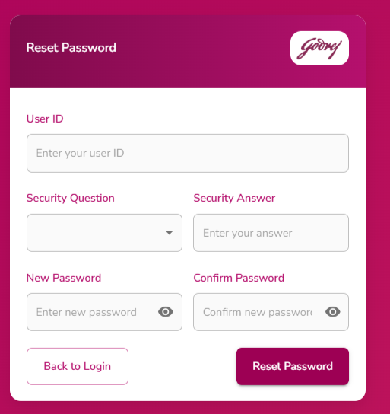
Purpose: Lets a user who forgot their password set a new one, without needing an Admin.
Buttons and what they do:
- Reset Password button: Verifies the security answer matches what was saved during registration. If correct, the password is updated, a success message is shown, and you are automatically returned to the Login page after 3 seconds. If the security answer does not match, or passwords don't meet the rules, an error is shown and nothing is changed.
- "Back to Login" button: Cancels the reset and returns to the Login page.
Important notes: You must know the exact Security Question and Answer chosen at registration time — there is no other way to verify identity on this page.

3. Dashboard

Dashboard
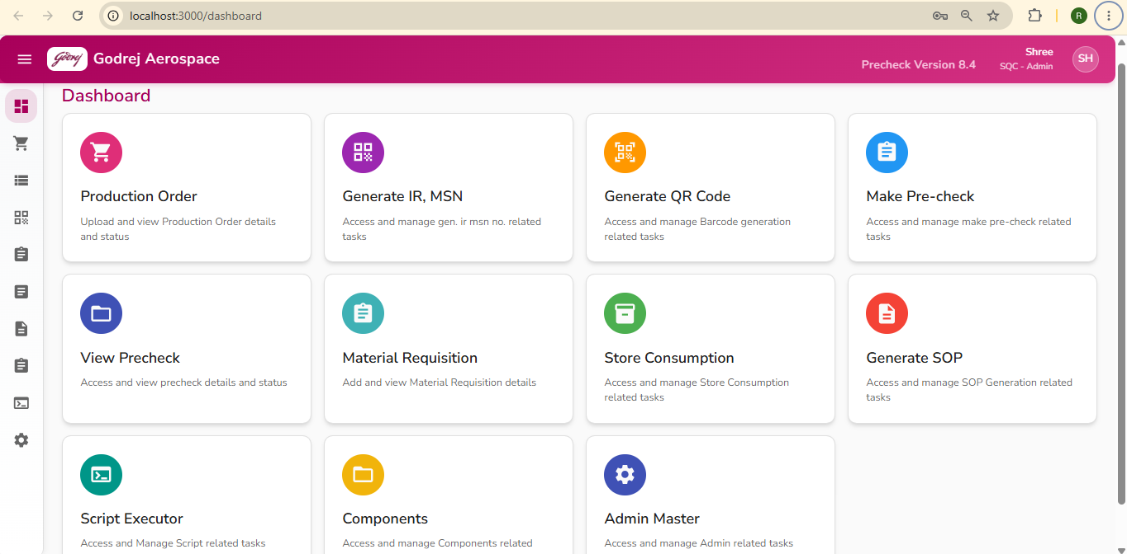
Purpose: A home-screen with shortcut cards to the most commonly used pages, so users can jump straight to their daily tasks without opening the sidebar menu.
Buttons and what they do: Each card on the Dashboard acts as a button — clicking anywhere on a card takes you straight to that page:
- Production Order card: Opens the Upload Orders page (or, for roles without upload access, the Pending For Precheck page for their role).
- Generate IR, MSN card: Opens the Create IR/MSN page.
- Generate QR Code card: Opens the Generate QR Code page.
- Make Pre-check card: Opens the Make Precheck page.
- View Precheck card: Opens the View Precheck page.
- Material Requisition card: Opens the Material Requisition page.
- Store Consumption card: Opens the Store In page.
- Generate SOP card: Opens the View SOP page.
- Script Executor card: Opens the Script Executor page.
- Components card: Opens the View Assembly page.
- Admin Master card: Opens the Role Management page.
Important notes: Only cards for pages the logged-in user's role is allowed to access are shown — for example, a QC user will not see the Admin Master card. If a user's role has no access to the Dashboard itself, a message "You do not have access to the Dashboard" is shown instead of the cards.

4. Production Order Management

Upload Orders (Production Order Management)
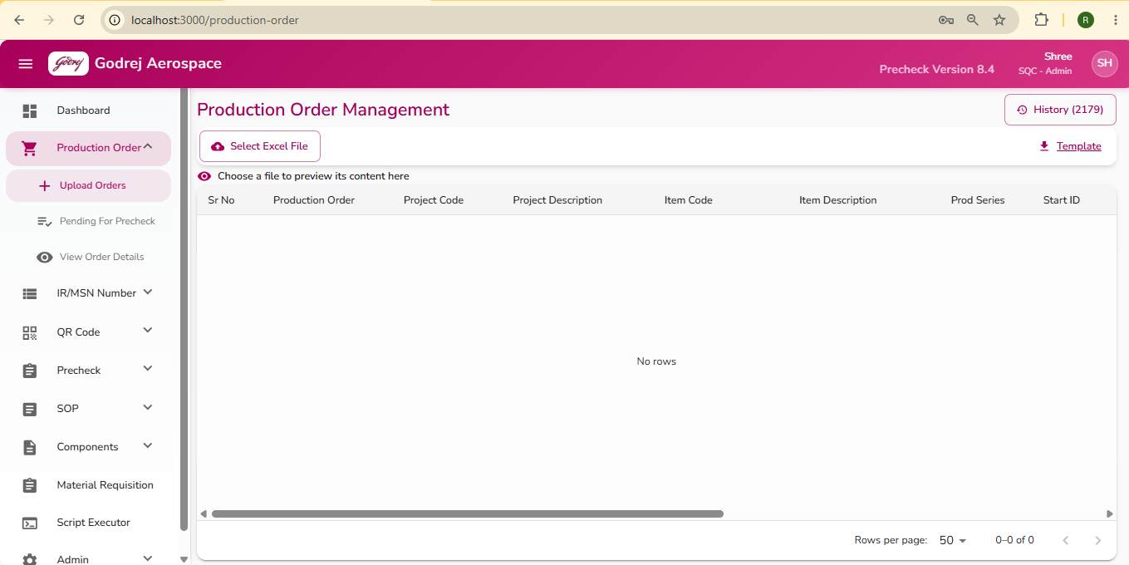

Example of the Production Order Excel Template downloaded via the Template button.
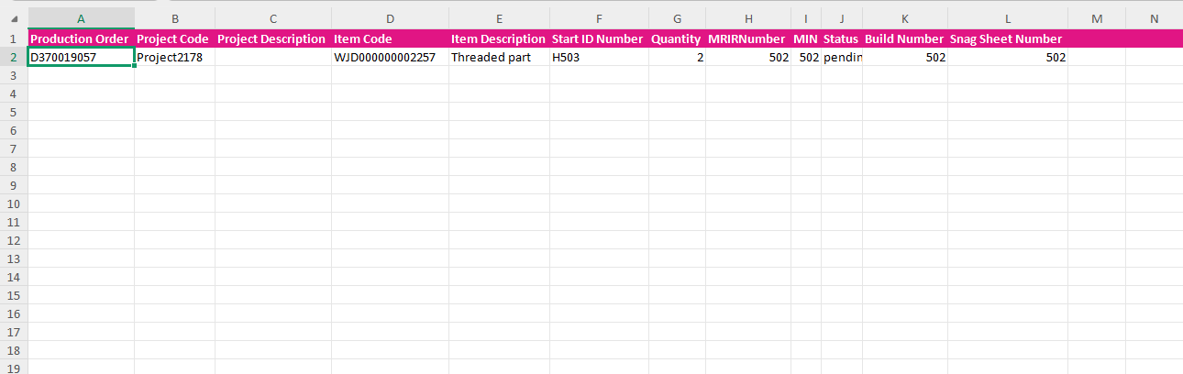

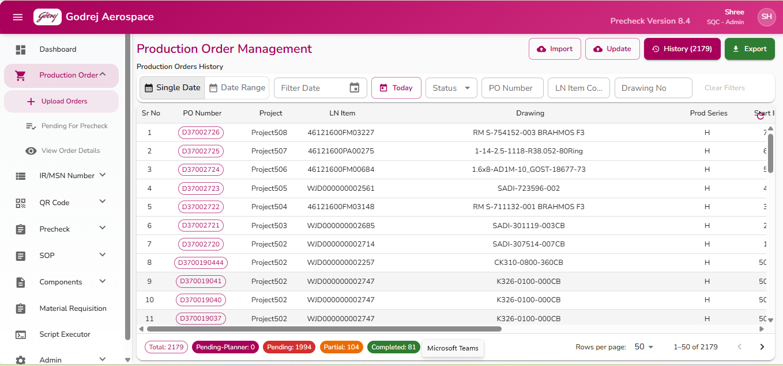

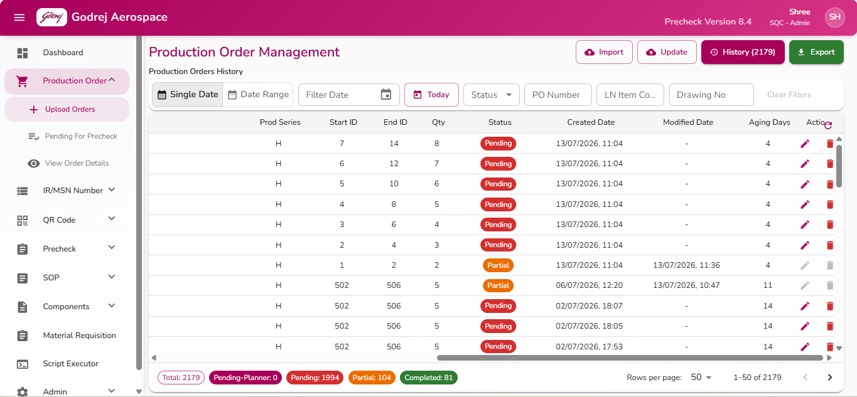
Purpose: This page is used to bring new Production Orders into the system by uploading an Excel file, to update existing orders in bulk, and to view/search/export the full history of all Production Orders already in the system.
Buttons and what they do:
- Import: Switches the screen to the Upload view in "Import" mode, ready to bring in brand-new Production Orders from an Excel file.
- Update: Switches the screen to the Upload view in "Update" mode, used when you want to bulk-update the MIN status of existing orders using an Excel file, instead of adding new ones.
- History (with count): Switches back to the History view listing all Production Orders. The number in brackets shows how many orders currently match your filters.
- Export: Asks "Do you want to export the Production Order data?" - if you confirm, it downloads an Excel file of the currently filtered Production Order list to your computer.
- Select Excel File / Select Excel for Update: Opens your computer's file browser so you can choose the Excel file (.xls or .xlsx only) to upload. Once chosen, a preview of its contents appears in a table below so you can check the data before confirming.
- Change Excel: Appears once a file is selected; lets you pick a different file instead.
- Confirm (Step 2): Appears only after a file has been selected. Sends the file to the system for processing. In Import mode this creates new Production Orders; in Update mode this updates the MIN status of matching existing orders. While processing, the button shows "Importing...".
- Template: Downloads a blank Excel template file showing the correct column layout to use when preparing your upload file.
- Refresh icon (top-right of history table): Reloads the history list and clears any advanced grid filter that may have been applied on a column.
- Edit icon (pencil, in each row's Actions column): Opens the Edit Production Order page for that row so its details can be corrected. Only enabled when the order's status is "Pending-Planner" or "Pending" - it is greyed out once an order has moved to Partial or Completed.
- Delete icon (bin, in each row's Actions column): Only enabled for orders still in "Pending-Planner" or "Pending" status. Clicking it does not delete immediately - it shows a Confirm (checkmark) and Cancel (X) icon in place of the row's normal actions. Clicking the checkmark permanently deletes that Production Order; clicking the X cancels the delete.
Important notes:
- Only .xls and .xlsx files can be uploaded; any other file type is rejected with a message.
- After a successful Import or Update, a "Successful!" popup appears. Clicking "View History" in this popup takes you back to the History view and refreshes the list; clicking "Close" just dismisses the popup.
- If the uploaded file has problems, an error summary appears listing what went wrong (e.g., rows skipped) so you can fix the source file and try again.
- Edit and Delete are only possible while an order is still Pending; once work has started on an order (Partial) or it is finished (Completed), these actions are locked.

Edit Production Order
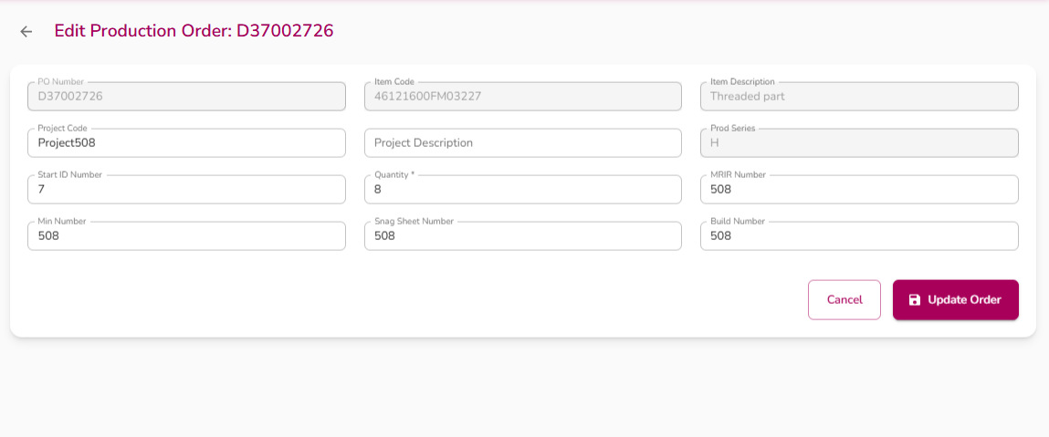
Purpose: This page lets you correct or fill in details for a single existing Production Order, such as project information, quantity, MRIR number, MIN number, snag sheet number, and build number.
Buttons and what they do:
- Back arrow (top-left): Returns you to the page you came from (Upload Orders history or Pending For Precheck) without saving changes.
- Cancel: Same as the back arrow - discards changes and returns to the previous page.
- Update Order: Saves your changes. While saving, the button shows "Updating..." with a spinner. On success, a green confirmation message appears and you are automatically returned to the previous page (with its list refreshed) after about 1.5 seconds. If the update fails, an error message is shown instead and you stay on the page so you can retry.
Important notes:
- PO Number, Item Code, Item Description, and Prod Series cannot be edited from this screen - only the other fields listed above can be changed.
- Quantity cannot be left blank or set to zero.

Pending For Precheck
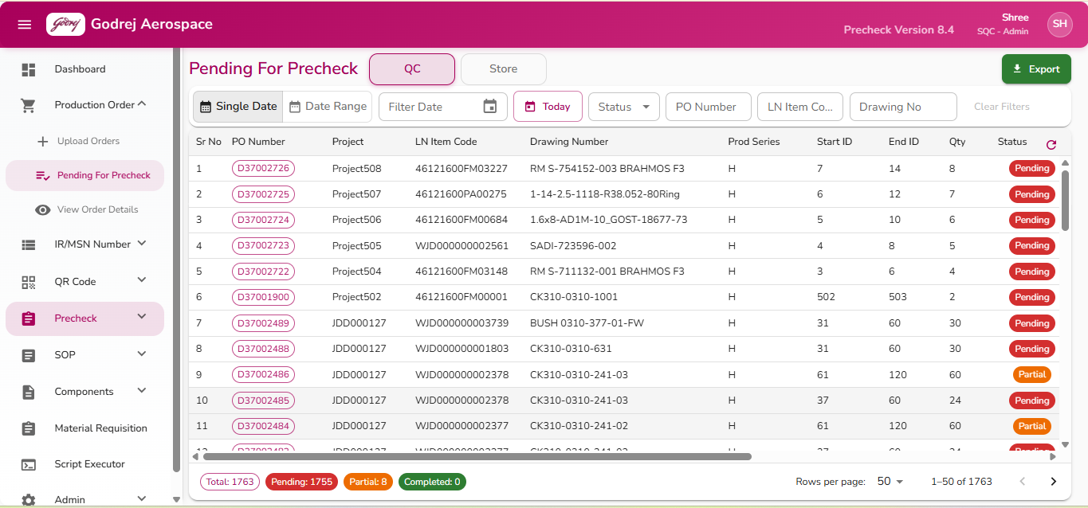

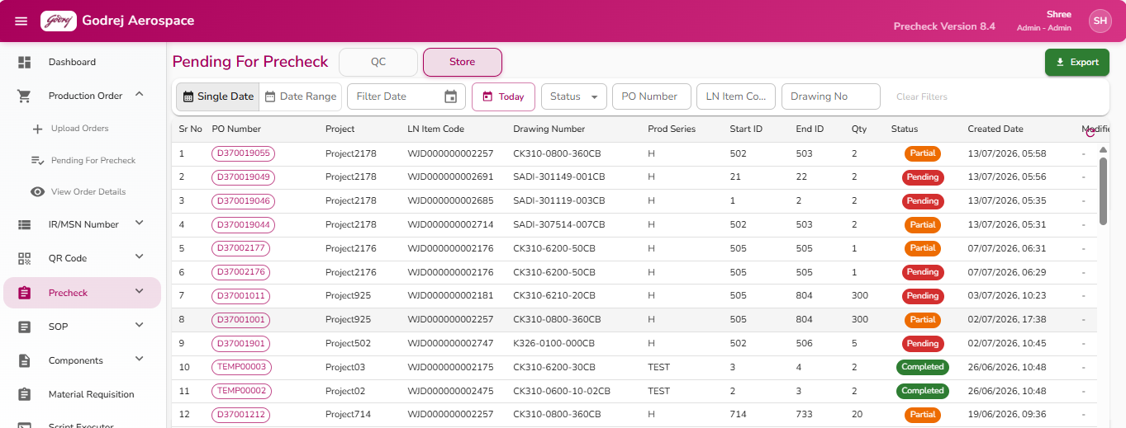
Purpose: This page lists Production Orders that are awaiting precheck action, so QC and Store staff can find the orders they need to inspect, view, or process next.
Buttons and what they do:
- Export: Asks for confirmation ("Do you want to export the Production Order data?"), then downloads the currently filtered list as an Excel file.
- Refresh icon: Reloads the list and clears any advanced column filter.
- View (eye icon, per row): Opens the "View Order Details" page for that Production Order, showing its BOM and available QR codes. This is greyed out with a tooltip explaining "You do not have permission to view precheck details" if your role does not allow it.
- Make Precheck icon (checklist icon, per row): Opens the Make Precheck page/screen for that order so QC/Store can begin performing the precheck. Greyed out with a "you do not have permission" tooltip if not allowed for your role.
- Edit icon (pencil, per row): Opens the Edit Production Order page for that order. Only enabled while the order's status is Pending or Pending-Planner.
- Delete icon (bin, per row): Only enabled while status is Pending or Pending-Planner. Clicking shows Confirm/Cancel icons in place of the row actions - confirming permanently deletes the order, cancelling backs out without deleting.
Important notes:
- The View and Make Precheck actions may be visible but disabled (greyed out) depending on what your specific user role is permitted to do - hover over the icon to see why.
- Just like the Upload Orders history screen, Edit and Delete only work while an order is still Pending; they lock once the order has moved further along.

View Order Details
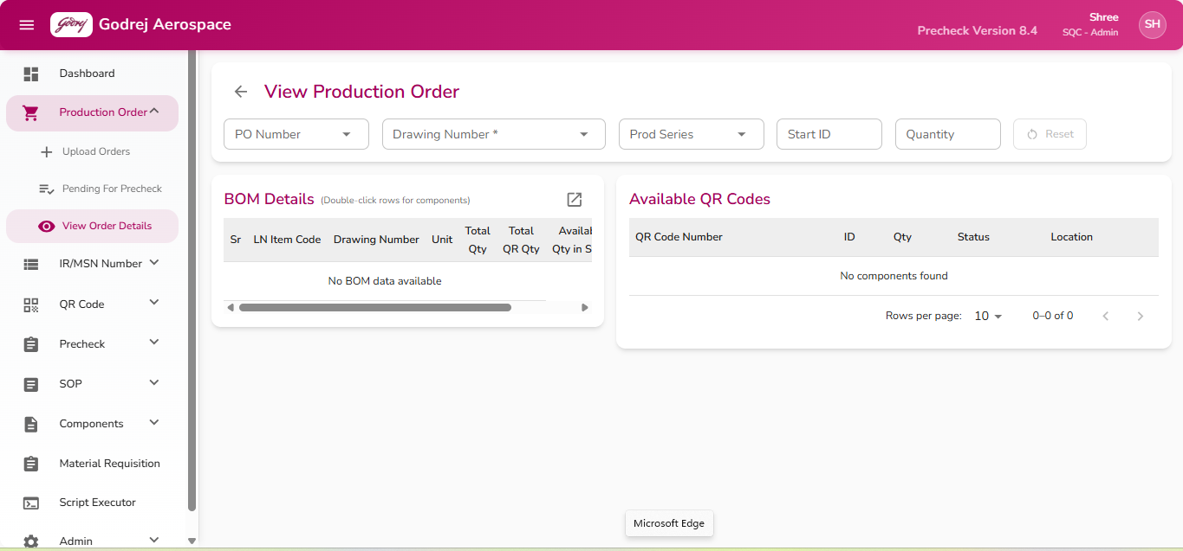
Purpose: This page lets you look up a specific Production Order and see full details about it, including its Bill of Materials (BOM) and which QR-coded components/parts are currently available in the store for it.
Buttons and what they do:
- Back arrow (top-left): Returns to the previous page you came from.
- Reset (with refresh icon): Clears the PO Number, Drawing Number, Prod Series, Start ID, Quantity, and both the BOM and QR Code tables, returning the page to a blank state. This button is only enabled once you have entered/selected something to reset.
- Expand icon (on BOM Details panel): Opens the BOM table in a larger popup window for easier viewing, useful when there are many BOM rows. Close it with the X in the popup's top-right corner.
- Double-clicking a row in the BOM Details table: This is the key interaction on this page - double-click any BOM row to load the list of available QR-coded components for that specific part into the "Available QR Codes" table on the right. The selected row is highlighted in light blue while its QR codes are loading.
Important notes:
- You must select a Production Order first (or arrive here already carrying one from another page) before the BOM table will show any data.
- The Available QR Codes list only populates after you double-click a row in the BOM table - simply selecting a Production Order does not automatically load QR codes for every part.
- If Production Series is missing/not found for the order, double-clicking a BOM row will show an error instead of loading QR codes.

5. IR/MSN Number

View All IR/MSN
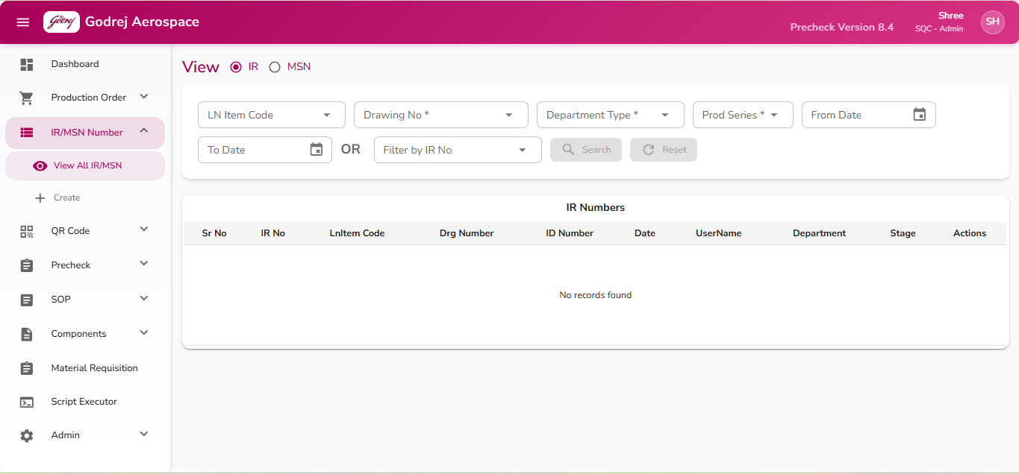
Purpose: Lets any user search for IR or MSN numbers that have already been created in the system, see their details in a table, and open a record to edit it.
Buttons and what they do:
- Search: Loads the table of matching IR or MSN records. This button is greyed out (disabled) until either (a) a Production Series is chosen, (b) both a From Date and To Date are chosen, or (c) a specific IR/MSN number is picked from the "Filter by" box. After searching, a message appears showing how many records were found, or "No records found for the selected criteria" if nothing matches.
- Reset: Clears every filter box and empties the results table. This button is greyed out if nothing has been filled in or searched yet.
- Edit icon (pencil, at the end of each row): Opens the Edit IR/MSN page for that specific record so its details can be updated.
Important notes:
- Production Series is mandatory for a search unless you either select a date range or pick a specific IR/MSN number directly.
- If you leave this page and come back, your last search filters and results are automatically restored.

Edit IR/MSN
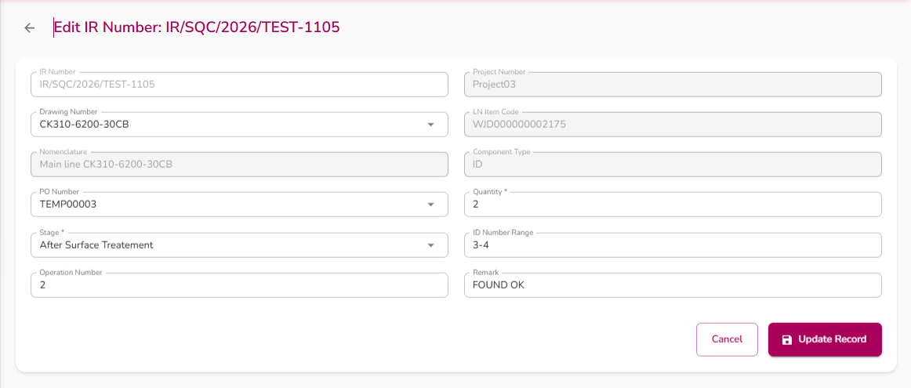
Purpose: Update the details of one existing IR or MSN record (for example, its drawing, quantity, stage, PO number, or remark) after it has already been created.
Buttons and what they do:
- Back arrow icon (top left): Leaves the page and returns to the previous screen without saving any changes.
- Cancel: Same as the back arrow — returns to the previous screen, discarding any unsaved changes.
- Update Record: Saves the changes. While saving, the button shows "Updating...". Once successful, you are taken back to the "View All IR/MSN" page automatically.
Important notes:
- If some details (like Supplier) were not carried over from the View page, the system automatically tries to fetch them from the server in the background.

Create (Generate IR/MSN Number)
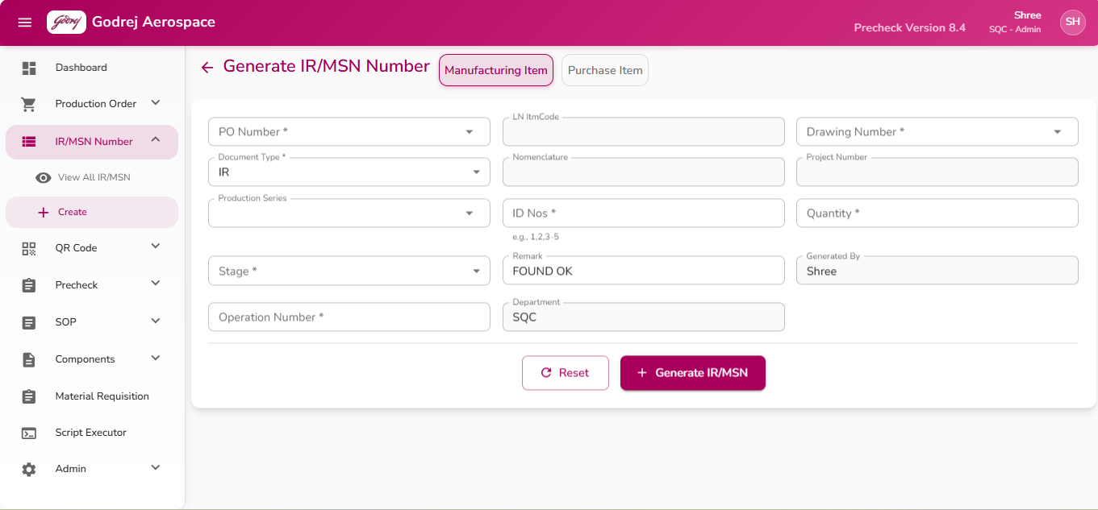
Purpose: Used to generate a brand-new IR or MSN number for either a manufacturing item or a purchased item, based on a Production Order (PO), drawing, and a range of ID numbers.
Buttons and what they do:
- Manufacturing Item / Purchase Item toggle: switches which of the two entry forms is shown. Each tab keeps its own separate set of entered values.
- Reset: Clears all fields on the currently open tab back to their starting values (your Department stays filled in).
- Generate IR/MSN: Submits the form and creates the new IR or MSN number. While working, the button shows "Generating...". Once successful, the new number appears in a highlighted box on screen.
- Copy icon (next to the generated number): Copies the generated IR/MSN number to the clipboard; the icon briefly turns into a checkmark to confirm the copy worked.
- Download Memo (only appears after generating an MSN number, and only for QC/Admin users): Downloads a PDF memo for that MSN number. Shows "Downloading Memo..." while in progress.
Important notes:
- Quantity is always worked out automatically from the ID Nos/ID Range you type — you do not enter it directly.
- If a PO Number is selected, the ID range you enter is checked against that PO's assigned Start/End ID numbers; entering IDs outside that range gives an on-screen error explaining the valid range.

6. QR Code

View QR Code
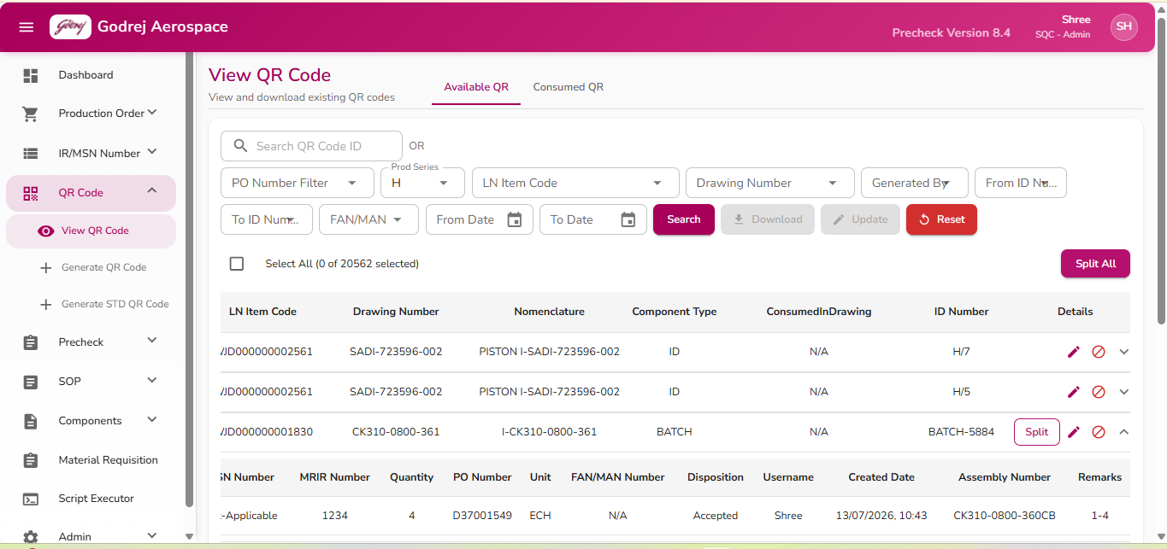

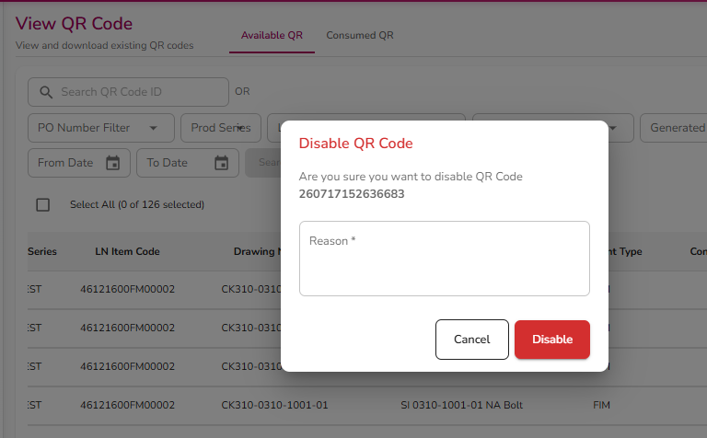
Purpose: Search for QR codes that have already been generated, view their full details, download them, disable ones that should no longer be used, or bulk-update several at once. Also used to view QR codes that have already been consumed (used up) in production.
Buttons and what they do:
- Search: Runs a search using the filter fields (Prod Series, Drawing Number, dates, etc.). Disabled if you have typed something in the QR Code ID box, or if no filter has been chosen.
- Download: Downloads the QR code(s) currently checked in the table. Disabled until at least one row is checked.
- Update (hidden while on the Consumed QR tab): Opens the Bulk Update dialog for the checked rows. Only becomes enabled when every checked QR code is the same "ID" component type and shares the same LN Item Code, Drawing Number, Production Series, PO Number and creation date.
- Reset: Clears every filter, the search box, and the results table.
- Select All checkbox (above and inside the table): Ticks or un-ticks every visible row at once.
- Split All / Close All: For eligible "Batch" type QR codes (unit "ECH", quantity greater than 1), splits each one into individual rows (one per unit) so they can be handled separately; pressing it again while already split collapses them back together.
- Edit icon (per row): Opens the Update QR Code page for that record.
- Disable icon (per row, red block symbol): Opens a confirmation pop-up asking for a reason, then disables that QR code so it can no longer be used. Greyed out if the code is already disabled.
- Expand arrow (per row): Shows/hides extra details for that QR code — Status, IR Number, MSN Number, MRIR Number, Quantity, PO Number, Unit, FAN/MAN Number, Disposition, Username, Created Date, Assembly Number, and Remarks.
- Split/Close (per row, only shown for eligible Batch-type rows): Splits that single row into multiple rows, or collapses previously split rows back into one.
Disable QR Code pop-up:
- Reason text box (required) — you must type a reason before you can confirm.
- Cancel / Disable buttons.
Bulk Update pop-up:
- Shows read-only details of the selected item(s), plus editable Project Number, Unit, IR, MSN, and MRIR fields.
- Cancel / Update buttons — Update applies the changes to every checked QR code at once.
Important notes:
- The QR Code ID search box is designed for barcode scanners: a full 12- or 15-digit scan triggers the search automatically without needing to press any button.
- Filter-based Search only works when the QR Code ID box is empty.

Update QR Code
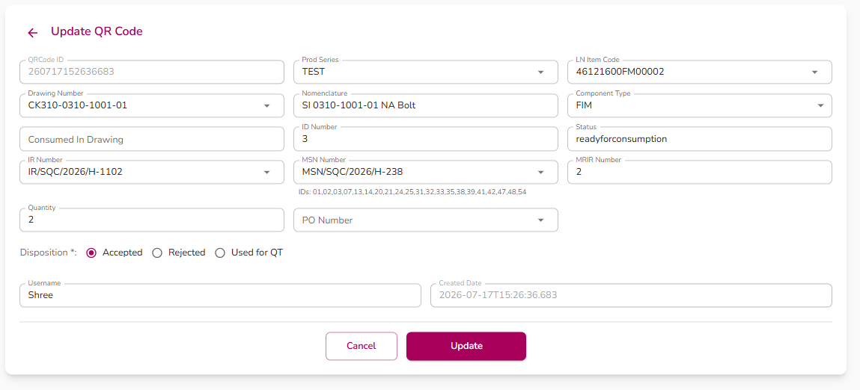
Purpose: Update the details of a single existing QR code record — for example, its linked drawing, IR/MSN number, quantity, disposition, or remarks.
Buttons and what they do:
- Back arrow icon (top left): returns to the previous page.
- Cancel: returns to the "View QR Code" page without saving.
- Update: saves only the fields that were actually changed. Shows "Updating..." while in progress. On success, shows a confirmation message and automatically returns to the "View QR Code" page after about 1.5 seconds.

Generate QR Code
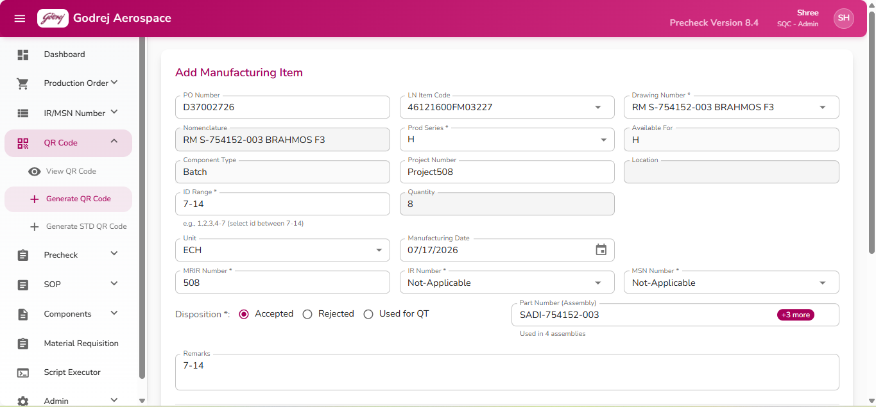

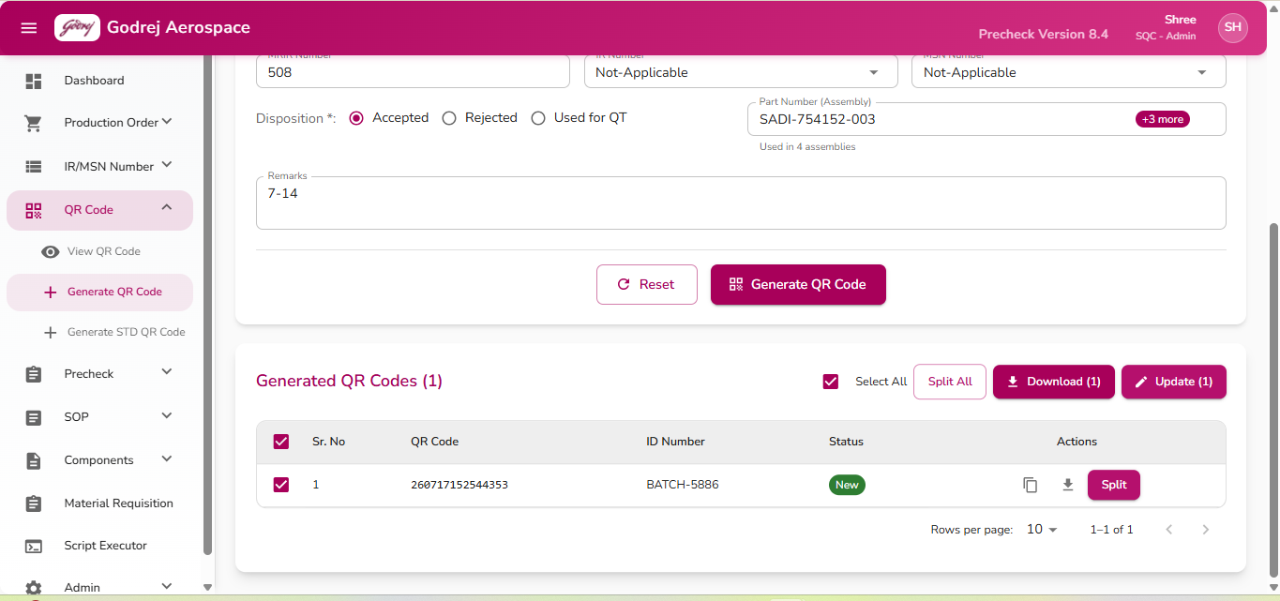

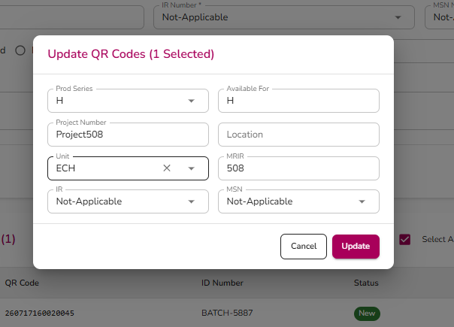
Purpose: Create new QR codes/labels for manufacturing items, covering three kinds of components: individually-numbered ("ID") items, "Batch" items, and FIM/SI items.
Buttons and what they do:
- Reset: Clears the entire form back to blank/default values.
- Generate QR Code: Creates the QR code(s) based on what was entered. On success, shows a message with how many new codes were created. If some of the ID numbers you requested already have QR codes, a pop-up lists which ones already exist so you can review them.
- In the Generated QR Codes results table: Select All checkbox, Download (for checked rows), Update (opens Bulk Update dialog for checked rows), per-row Copy icon (copies that QR code number), per-row Download icon, per-row Split/Close button (for eligible Batch/ECH rows), and a Split All/Close All button for the whole table.
- Existing QR Codes pop-up: lists ID numbers that already had QR codes; only has a Close button.
- Bulk Update pop-up (for checked rows in the results table): editable Prod Series, Available For, Project Number, Location, Unit, MRIR, IR, MSN fields, with Cancel / Update buttons.
Important notes:
- You never type Quantity directly — it is always calculated from the Start/End IDs, the ID Range, or the number of Random ID boxes filled in.
- If the chosen Drawing Number contains "CB", the MRIR Number field is not required and is disabled.

Generate STD QR Code
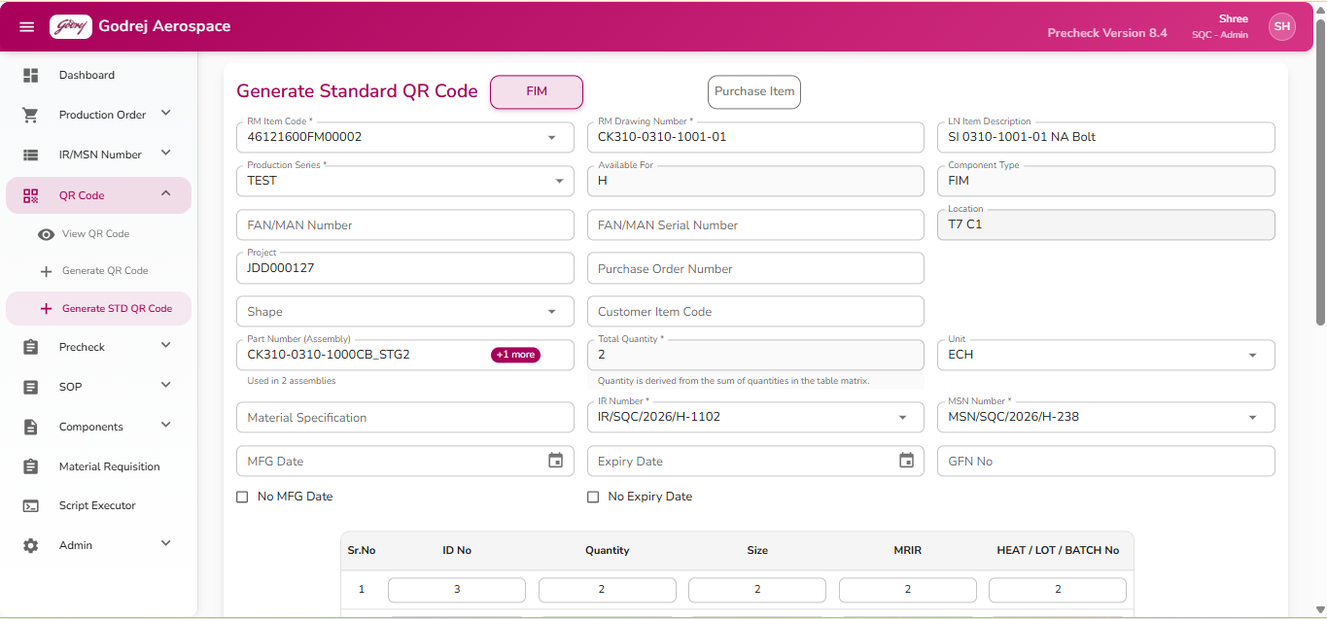

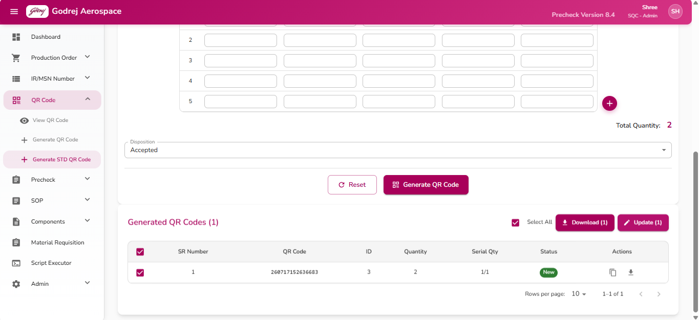

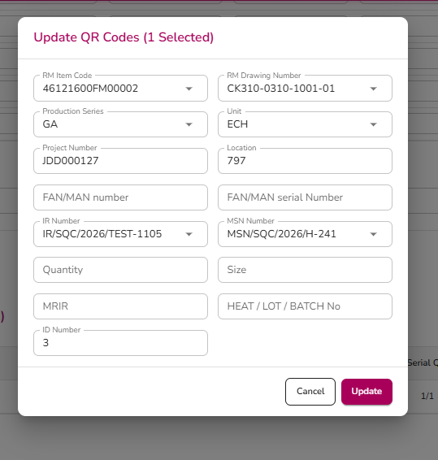
Purpose: Generate "Standard" QR codes using a row-by-row data entry table — useful when many individual items (each with its own ID, quantity, size, MRIR and heat/lot number) need QR codes generated together in one go. Covers two item types: FIM (manufactured item) and Purchase Item (SI) — the system picks the type automatically based on the drawing selected, or it can be switched manually.
Buttons and what they do:
- FIM / Purchase Item toggle: switches the item type, which shows or hides the FAN/MAN, Customer Item Code, MRIR and GFN No fields.
- Add Row (+ icon) next to the table: adds another blank row.
- Reset: clears the whole form and puts the table back to 5 blank rows.
- Generate QR Code: checks that RM Item Code, Production Series, Unit and a valid quantity are filled in, then creates one QR code for every table row that has an ID No entered. Shows a success message when done.
- In the Generated QR Codes results table: Select All, Download (checked rows), Update (checked rows, opens Bulk Update dialog), and per-row Copy/Download icons.
- Bulk Update pop-up: editable RM Item Code, Production Series, Unit, Project, Location, FAN/MAN Number & Serial, MRIR, Heat/Lot, Size, ID Number, IR, MSN fields, with Cancel / Update buttons.
Important notes:
- If two rows in the table are given the same ID Number, a red warning message appears automatically listing the duplicate(s) — this should be corrected before generating.
- Total Quantity cannot be typed directly; it is always the sum of the table's Quantity column.

7. Precheck Module

Precheck Overview (landing page)
📷 Screenshot not yet provided
Please add a screenshot of the “Precheck Overview (landing page)” screen here.

Purpose: This is a general overview/summary screen for precheck records — assemblies, their status, and their priority — with search, a details popup, and quick-action buttons.
Buttons and what they do:
- Refresh: Reloads the full precheck list from the system and clears any search text or filters you had set, taking you back to the first page of the list.
- Filter: Present on the toolbar, but currently does not open any filter options when clicked.
- Export: Present on the toolbar, but currently does not export or download anything when clicked.
- Process (on each row, table view — green checkmark icon, or "Process" on mobile cards): Attempts to run a precheck action for that assembly row and then refreshes the list. While this is running, the button is disabled to prevent double-clicks.
- View Details icon (eye icon on each row): Opens a popup window showing that record's Assembly Number, Drawing Number, Status, Priority, and Description.
- Edit icon (pencil icon on each row): Present on each row, but currently does not open an edit screen when clicked.
- Click anywhere on a row (or on a mobile card): Opens the same Details popup described above.
- "More / Less" (mobile card view only): Expands or collapses the card to show extra description text and two extra buttons ("View Details" and "Edit") which currently do not perform any action.
- In the Details popup — Close: Closes the popup without making any changes.
- In the Details popup — Edit: Present in the popup, but currently does not do anything when clicked.
- In the Details popup — Process: Present in the popup, but currently does not do anything when clicked.
- "+" floating button (mobile view only, bottom-right corner): Present on screen, but currently does not open any create-precheck screen when clicked.
Important notes:
- Several buttons on this screen (Filter, Export, Edit, and the popup's Edit/Process buttons) are visible but not yet wired up to any action — clicking them currently does nothing. Only Refresh, the row/card "Process" action, and opening/closing the Details popup are fully working.
- Status is shown as a coloured label: green for Completed, blue for In Progress, orange/yellow for Pending, red for Failed.
- Priority is shown as a coloured label: red for High, orange for Medium, green for Low.
- This page is a general-purpose overview and is separate from the "Make Precheck" workflow, which is documented separately.

View Precheck
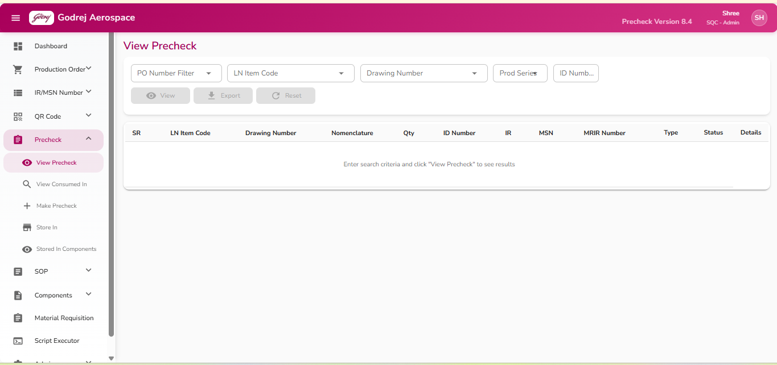
Purpose: Lets staff look up existing precheck records for a Production Order, LN Item Code, Drawing Number, Production Series, or an ID Number, and review the full detail of each matching item, including quantity, IR/MSN/MRIR numbers, remarks, and rejection status.
Buttons and what they do:
- View: Looks up precheck records matching whatever combination of PO Number, LN Item Code/Drawing Number, Production Series, and ID Number you have filled in, and displays them in the results table below. This button is greyed out (disabled) until at least one search field has a value.
- Export: Downloads/exports the currently filtered search criteria's precheck details. Greyed out until at least one search field has a value. If somehow clicked with nothing filled in, a message appears asking you to enter at least one search criterion first.
- Reset: Clears every search field and any results shown, returning the screen to its starting state. Greyed out unless there is something to clear.
- Expand/collapse arrow (on each result row, "Details" column): Opens a small sub-table under that row showing Remarks, the User who last touched the record, and the Date it was last modified/created.
- Column headers (SR, LN Item Code, Drawing Number, Nomenclature, Qty, ID Number, IR, MSN, MRIR Number): Click a column header to sort the results table by that column; click again to reverse the sort order.
Important notes:
- A component's Type is shown with a small icon/label: ID, BATCH, FIM, or SI.
- Each row also shows a Status label: "REJECTED" (grey background, dimmed row) if the item was rejected, or "ACTIVE" (green) otherwise. Rows already marked precheck-complete are shown slightly dimmed/shaded for visual reference.
- Results can be paged (5/10/25/50 rows per page) using the pagination bar under the table.
- Before any search is run, the table shows a message: "Enter search criteria and click 'View Precheck' to see results."

View Consumed In
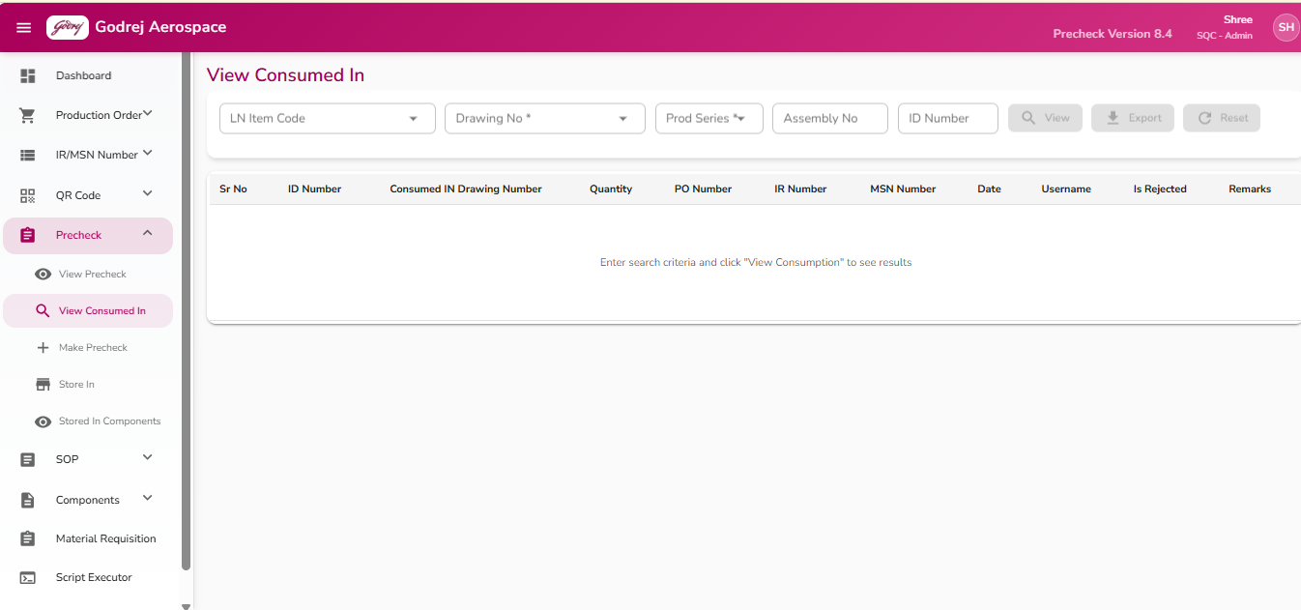
Purpose: Lets staff check where a given component (by Drawing Number and Production Series, optionally narrowed by ID Number or Assembly Number) was ultimately consumed/used, including the consuming drawing, PO number, and whether it was rejected.
Buttons and what they do:
- View: Looks up consumption records for the selected Drawing Number and Production Series (plus any optional ID/Assembly Number entered), and shows them in the results table. If Drawing Number or Production Series is missing, a message pops up asking you to select both before continuing. Greyed out until you have entered some search criteria.
- Export: Downloads the same filtered results as an export file. Same requirement — Drawing Number and Production Series must both be selected, otherwise a message asks you to select both. Shows a spinner while the download is in progress.
- Reset: Clears every search field and any displayed results back to the starting state. Greyed out unless there is something to clear.
- Column headers (Sr No, ID Number, Consumed In Drawing Number, Quantity, PO Number, IR Number, MSN Number, Date, Username, Is Rejected, Remarks): Click to sort the results table by that column; click again to reverse the order.
Important notes:
- The "Is Rejected" column shows "Yes"/"No"/"-" and the "Remarks" column shows the rejection reason if there is one, or "-" if not.
- Results can be paged (5/10/25/50 rows per page).
- Before running a search, the table shows: "Enter search criteria and click 'View Consumption' to see results."
- If a search runs but finds nothing, the table shows "No records found."
*Note: "Make Precheck" (Sidebar → Precheck → Make Precheck, available to Admin, Store, and QC) is covered in a separate document and is not described in detail here.*

Make Precheck
The "Make Precheck" page is where QC and Store staff verify that the correct physical parts (components) have been gathered for a particular assembly before those parts are stored or issued further. The user picks an assembly (by Production Order, Drawing Number, Production Series and ID Number), the system pulls up the full list of parts required for that assembly (the Bill of Material, or "BOM"), and the user then scans or enters each part's QR code to mark it as checked/accepted. Faulty parts can be rejected on the spot, and once all required parts are checked, the batch is submitted and permanently recorded. This page is available to Admin, Store, and QC users, and is reached from the left sidebar under Precheck > Make Precheck.
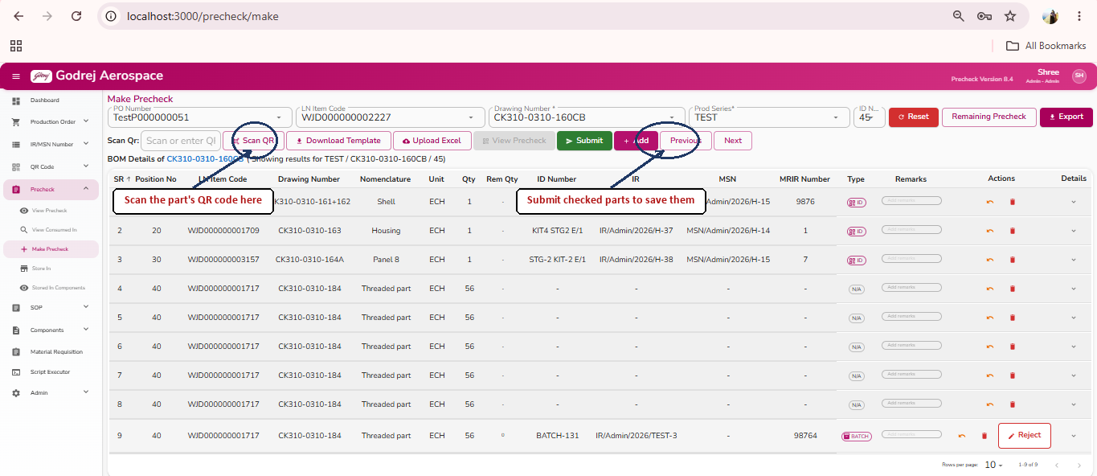

Example of the BOM Excel Template downloaded via the Download Template button on Make Precheck.
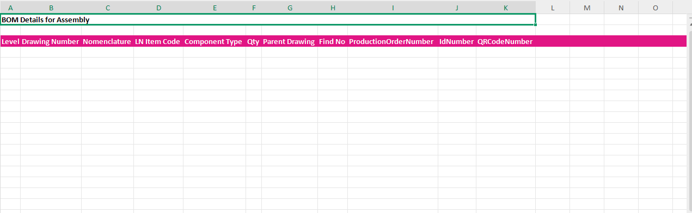

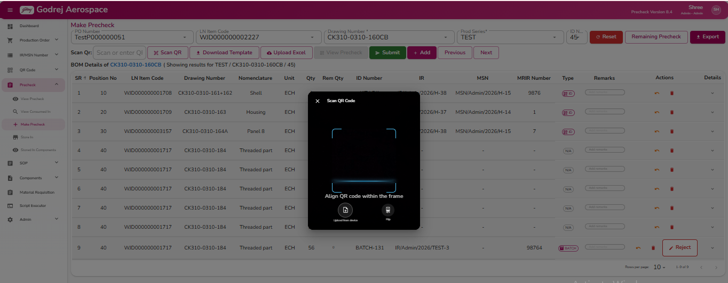

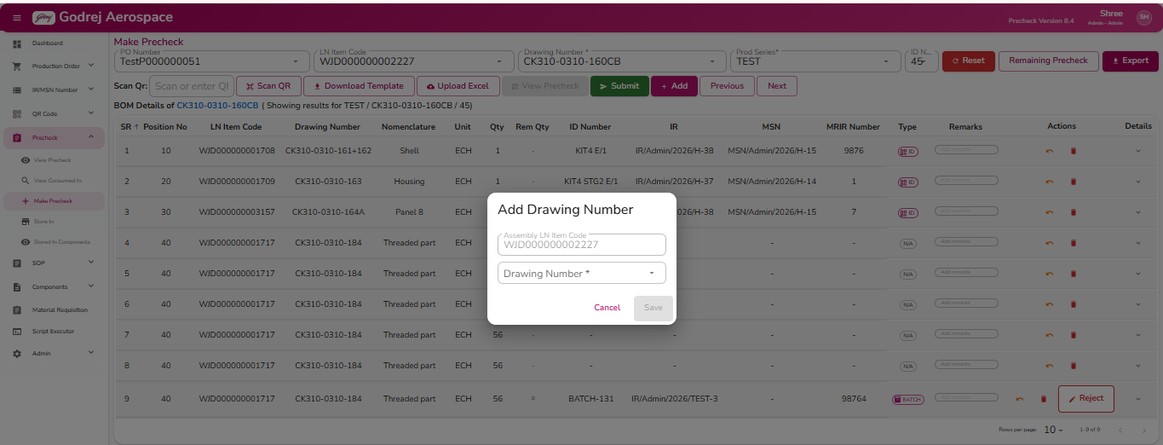

Step-by-Step Usage
- Open Precheck > Make Precheck from the left sidebar.
- (Optional) Search for and select a PO Number. If found, the system automatically fills in the matching Drawing Number, Production Series, and ID Number for you.
- If you did not use a PO Number, manually fill in:
- LN Item Code or Drawing Number (either box can be used to find and pick the assembly drawing)
- Prod Series
- ID Number
All three are required.
- Click the View Precheck button. The system loads the list of parts (BOM) needed for that assembly, showing each part's quantity, remaining quantity, and current status.
- For each part in the list, check it in one of these ways:
- Type or scan its QR code into the Scan Qr box, or click Scan QR to open the camera scanner.
- Use the Add button on a row to register a QR code by typing it in instead of scanning (Add QR Code dialog).
- Upload a prepared Excel sheet of QR codes using Upload Excel (a blank sheet can be obtained first via Download Template).
- If the scanned part is a "BATCH" type item, a pop-up will ask you to enter how much quantity from that QR code should be applied to this part. Enter the amount and click Confirm.
- If a part turns out to be damaged/incorrect, click Reject on that row, fill in the required remarks, and confirm. The row is split into a rejected row (greyed out, shown in red) and a fresh duplicate row where a replacement part can be scanned.
- If you scanned something by mistake and have not yet clicked Submit, click Undo on that row to reverse it.
- Once you are done checking parts (all or some), click Submit. All checked-but-not-yet-submitted rows are sent and permanently recorded. The list refreshes to show the latest status from the system.
- Use Previous / Next to move to the neighbouring ID Number under the same PO and repeat the process, Remaining Precheck to show only parts still pending, and Export to download the current list to Excel.
- Admin/Head users additionally have access to Add (to add a missing part/drawing to the BOM) and to Undo Precheck / Delete Precheck on already-stored rows, for corrections.

Search / Filter Fields (top bar)
Purpose: Lets the user pick which assembly's part list to load, and provides Reset, filter, and Export controls.
Buttons and what they do:
- Reset – clears all search fields and the loaded part list, starting over. If there are parts that have been scanned but not yet submitted, a warning pop-up appears first (see "Unsubmitted Changes" dialog below) and the reset does not happen until those are submitted.
- Remaining Precheck / Show All – toggles the parts list between showing everything and showing only parts still "Pending" or "Updated" (i.e., not yet fully completed). The button label switches to "Show All" when the filter is active. Disabled until a BOM has been loaded.
- Export – downloads the current precheck list to an Excel file, based on whichever search fields are filled in (PO Number, Drawing Number, Prod Series, ID Number) and whether the "Remaining Precheck" filter is on. If no search field is filled in, a message asks the user to enter at least one search criterion first. Disabled until a BOM has been loaded.

QR Scan Bar and BOM Header
Purpose: The main working area for scanning/entering parts, loading the BOM, and submitting the checked parts.
Buttons and what they do:
- Scan QR – opens the camera scanner to scan a QR code using the device camera. Disabled until a BOM is loaded.
- Download Template – downloads a blank Excel template file used for bulk QR code entry.
- Upload Excel – opens a file picker to upload a filled-in Excel sheet of QR codes for bulk checking. Shows a results pop-up after processing (see Excel Upload Result dialog).
- View Precheck – loads the part list (BOM) for the Drawing Number / Prod Series / ID Number currently entered. Only enabled once all three required fields are filled in and the combination is different from what is already loaded (and the ID Number is within the valid range for the selected PO). If there are unsubmitted scanned parts already on screen, a warning pop-up appears first and the new list will not load until those are submitted.
- Submit – sends all parts that have been scanned/checked but not yet submitted to the system, permanently recording them. If nothing has been scanned yet, a message says there is nothing to submit. Enabled only once a BOM has been loaded.
- Add *(Admin/Head only)* – opens the Add BOM Drawing dialog to add an extra part/drawing to the currently loaded assembly's part list.
- Previous – moves to the previous ID Number (within the same PO's ID range) and automatically reloads its part list. Disabled if there is no previous ID Number or only one ID Number exists.
- Next – moves to the next ID Number and automatically reloads its part list. Disabled if there is no next ID Number or only one ID Number exists.
The text beneath the buttons shows "BOM Details of [Drawing Number]" and, once loaded, "Showing results for [Prod Series] / [Drawing Number] / [ID Number]" so the user always knows which assembly is on screen.

BOM Details Table
Purpose: Shows every part required for the selected assembly, its checked/not-checked status, and lets the user act on each row (scan-related actions, reject, undo, remarks, and — for Admin/Head — undo/delete of stored records).
Columns: SR (serial number), Position No, LN Item Code, Drawing Number, Nomenclature, Unit, Qty (total quantity needed), Rem Qty (remaining quantity still to be checked), ID Number, IR, MSN, MRIR Number, Type (a colored tag: ID, BATCH, FIM, or SI), Remarks (free-text box, editable unless the row is already completed or submitted), Actions, and Details (an expand arrow).
Row appearance: a rejected part's row is greyed out with red text; a fully completed part's row is shown in light grey; double-clicking a row highlights it in light blue.
Buttons and what they do (per row):
- Add (only shown for BATCH-type parts that still have remaining quantity) – adds a new blank duplicate row underneath, so another QR code can be scanned against the remaining quantity of that same part.
- Undo Precheck (orange icon, only on rows that are already saved in the system and not currently being edited) – reverses a previously completed/stored precheck entry. Only Admin/Head users can use this; other users see it disabled with a tooltip explaining only Admin/Head can undo. It is also disabled while the row's status is still "Pending" (nothing to undo yet). Clicking it shows a confirm/cancel pair of icons before actually undoing.
- Delete Precheck (red trash icon, same rows as above) – permanently deletes that stored precheck entry. Only Admin/Head users can use this; others see it disabled with an explanatory tooltip. Clicking it shows a confirm/cancel pair of icons before actually deleting.
- Reject (only shown on rows the system has flagged as eligible for rejection, and not already rejected) – opens the Reject dialog to mark this part as rejected/faulty.
- Undo (only shown on a row just scanned in the current session that has not yet been submitted) – reverses that scan locally (clears the QR code, IR, MSN, remarks, etc. and restores the remaining quantity) so it can be re-scanned or left blank. This does not need Submit and does not affect anything already saved to the system.
- Rejected tag – shown instead of buttons once a row has been rejected; no action, just a status label.
- Expand arrow (Details column) – expands the row to show extra information: Remarks, the User who last updated it, the Date it was modified, and a Status tag (Completed = green, Updated = orange, Pending = grey).
Important notes:
- The Remarks box is disabled (cannot be edited) once a row is marked complete or already submitted.
- If several duplicate rows exist for the same part (from repeated "Add" actions on a BATCH part), only the most recent one is shown at full opacity; earlier ones are dimmed once superseded.

Quantity Dialog
Purpose: Appears automatically right after scanning a QR code for a "BATCH" type part, to ask how much of that scanned batch should be applied against the part currently needed.
Buttons and what they do:
- Cancel – closes the dialog without applying any quantity; the scan is discarded.
- Confirm – applies the entered quantity to the part's row and reduces its remaining quantity accordingly. Disabled until a valid quantity is entered.

Add QR Code Dialog
Purpose: Lets the user manually type in a QR code's details for a specific part row instead of scanning it with the camera — useful if a physical scan is not possible. Behind the scenes this registers the QR code, marks it as stored-in, and then immediately checks it against the row, in one step.
Buttons and what they do:
- Cancel – closes the dialog without making any changes.
- Add – registers and checks the entered QR code against the selected row. Disabled until Production Series, ID Number, and a valid 12- or 15-digit QR Code Number are all filled in.
Important notes:
- If the QR code being added belongs to a batch where an earlier QR code in the sequence has not been scanned yet, a message tells the user to scan that earlier one first.
- If the QR code is not yet "stored in" (still just generated) or has already been consumed elsewhere, the system blocks the action and shows an explanatory message instead of adding it.

Reject Dialog
Purpose: Used to mark a part as rejected (damaged, wrong, or otherwise unusable) and immediately create a replacement row so a substitute part can be checked in its place.
Buttons and what they do:
- Cancel – closes the dialog without rejecting anything.
- Reject Component – confirms the rejection. This splits the part into two rows: one rejected row (shown greyed out and in red) and one new duplicate row ready for a replacement part to be scanned. Disabled until both remarks boxes are filled in.

Add BOM Drawing Dialog (Admin/Head only)
Purpose: Lets an Admin/Head user add an extra part (drawing) to the Bill of Material of the currently selected assembly, in case a needed part is missing from the list.
Buttons and what they do:
- Cancel – closes the dialog without adding anything.
- Save – adds the selected drawing as a new part under the current assembly's BOM. Disabled until a drawing is selected. On success, a confirmation message appears and the part list reloads automatically to show the newly added part.

Excel Upload Result Dialog
Purpose: Shown automatically after uploading a bulk Excel file of QR codes, to summarize what succeeded and what failed.
Buttons and what they do:
- OK – closes the results pop-up.

Batch Warning Dialog
Purpose: Appears when scanning a QR code for a batch part, if an earlier QR code in that batch's sequence has not been scanned yet.
Message: "Previous QR code is not scanned, scan that QR code first."
Buttons and what they do:
- OK – closes the message. The user must scan the earlier QR code first before this one will be accepted.

Unsubmitted Changes Dialog (Reload/Reset Confirmation)
Purpose: Protects the user from losing scanned-but-not-yet-submitted work. It appears when clicking Reset or View Precheck while there are parts on screen that have been scanned but not yet submitted.
Message: "Please submit remaining precheck."
Buttons and what they do:
- OK – simply closes the message. Note: clicking OK does not proceed with the Reset or the reload — the user must first click Submit to save the pending scans (or Undo them) before Reset or View Precheck will actually run again.

Camera Permission Dialog
Purpose: Appears the first time (or any time the browser has not yet granted camera access) the user clicks Scan QR, to ask for permission to use the device camera.
Message: "To scan QR codes, we need your permission to access the camera. Would you like to allow access?"
Buttons and what they do:
- Deny – closes the dialog; the camera scanner does not open.
- Allow – asks the browser for camera permission. If the user grants it, the QR scanner opens right away.

QR Scanner Dialog (Camera View)
Purpose: Shows a live camera feed so the user can scan a part's QR code by pointing the device at it, as an alternative to typing the code manually.
On-screen elements:
- Live camera view with a scanning frame and an animated scan line, plus the hint "Align QR code within the frame."
- A loading spinner with "Starting camera..." while the camera is initializing.
- If the camera cannot start, an error message is shown instead of the camera feed, with a Close button.
- If an uploaded image could not be read as a QR code, an error banner appears at the top of the dialog.
Buttons and what they do:
- Close (X, top-left) – closes the scanner without scanning anything.
- Upload from device – lets the user pick an image file from their device (instead of using the live camera) that contains a QR code; the system reads the code from the image.
- Flip – switches between the rear camera and the front (selfie) camera.
Important notes:
- As soon as a QR code is successfully recognized by the camera, the dialog closes automatically and the code is looked up right away — no extra click is needed.

Business rules worth knowing (validation and status logic)
- A QR code entered anywhere on this page (Scan Qr box or Add QR Code dialog) must be exactly 12 or 15 digits, numbers only.
- Every scanned/entered QR code is checked against its current status before being accepted:
- If it is "generated but not stored in yet," the system blocks it and explains the part has not been stored in.
- If it has "already been consumed," the system blocks it and explains it cannot be reused.
- Only QR codes marked "Available" are accepted.
- For BATCH-type parts, the system will not let the same part row be marked complete until its Remaining Quantity reaches zero; scanning multiple QR codes against the same BATCH row (using the row's Add button) is expected until it's fully used up.
- For ID-type parts, each individual ID Number can only be assigned once per drawing — trying to reuse an already-assigned ID Number for the same drawing is blocked with a warning.
- Row status shown in the expanded Details area (Completed / Updated / Pending) reflects: Completed = fully checked and saved, Updated = scanned in this session but not yet submitted, Pending = not yet touched.

Store In
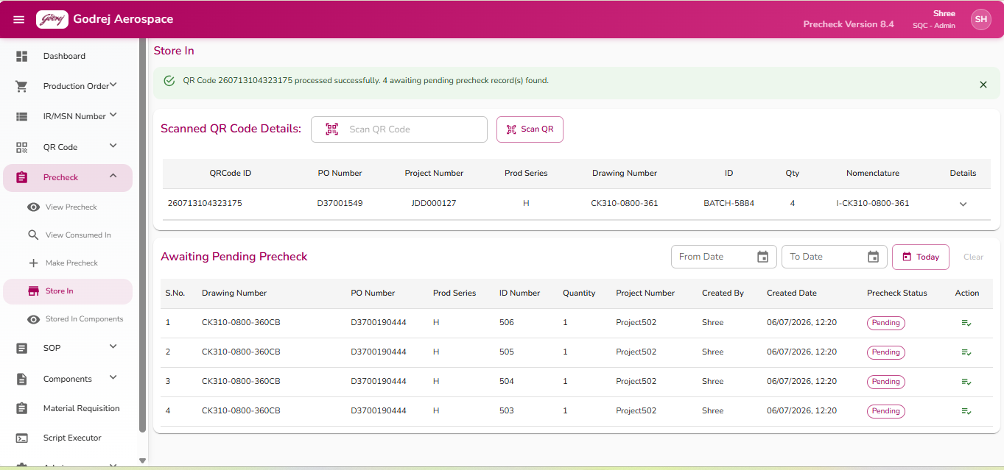
Purpose: Used by store staff to scan or enter a QR Code for an incoming component, confirm its details, and see the list of precheck items still awaiting storage-in action so they can be sent for "Make Precheck."
Buttons and what they do:
- QR scan icon (inside the text box) / "Scan QR" button: Opens the camera-based QR scanner. If the browser has not yet been given camera permission, a small "Camera Access" popup appears first, asking to Allow or Deny.
- Camera Access popup — Allow: Requests camera permission from the browser/device, then opens the live camera scanner window regardless of whether permission was actually granted.
- Camera Access popup — Deny: Closes the popup without opening the camera.
- Camera scanner window — Close (X icon): Closes the scanner without scanning anything.
- Camera scanner window — Flip (camera icon): Switches between the front-facing and rear-facing camera.
- Camera scanner window — Torch: Turns the phone/device's flashlight on or off, to help scan in low light (only works if the device supports it).
- Camera scanner window — Upload from device: Lets you choose an existing photo of a QR code from your device instead of scanning live; the system will try to read the code from that image.
- Today (in the Awaiting Pending Precheck filters): Sets both the "From Date" and "To Date" to today's date, showing only records created today. Disabled until a QR code has been scanned.
- Clear (in the Awaiting Pending Precheck filters): Clears the From/To date filters. Disabled until a date filter is set.
- Expand/collapse arrow (on the Scanned QR Code Details row): Shows extra information about the scanned item — Consumed in Drawing, Status, IR Number, MSN Number, MRIR Number, Disposition, Username, and Created Date.
- Make Precheck icon (checklist icon, in the Action column of the "Awaiting Pending Precheck" table): Takes you to the Make Precheck screen for that specific record (documented separately). If your role does not have permission to make a precheck, this icon is greyed out and hovering shows the message "You do not have permission to perform precheck."
Important notes:
- Scanning is designed to work automatically with a barcode/QR gun: if a 15-digit code is scanned it is processed immediately; if a 12-digit code is scanned, the system waits briefly (2 seconds) before processing it, in case more digits are still coming in from a fast scanner.
- After a successful scan, a message banner appears at the top confirming the QR Code was processed and stating how many pending precheck records were found for it (or that none were found).
- If the scanned QR Code has already been consumed, a message says so.
- The "Awaiting Pending Precheck" table lists items tied to the currently scanned QR Code; its Precheck Status is shown as a coloured label (e.g., Partial, Pending, Pending-Planner).

Stored In Components
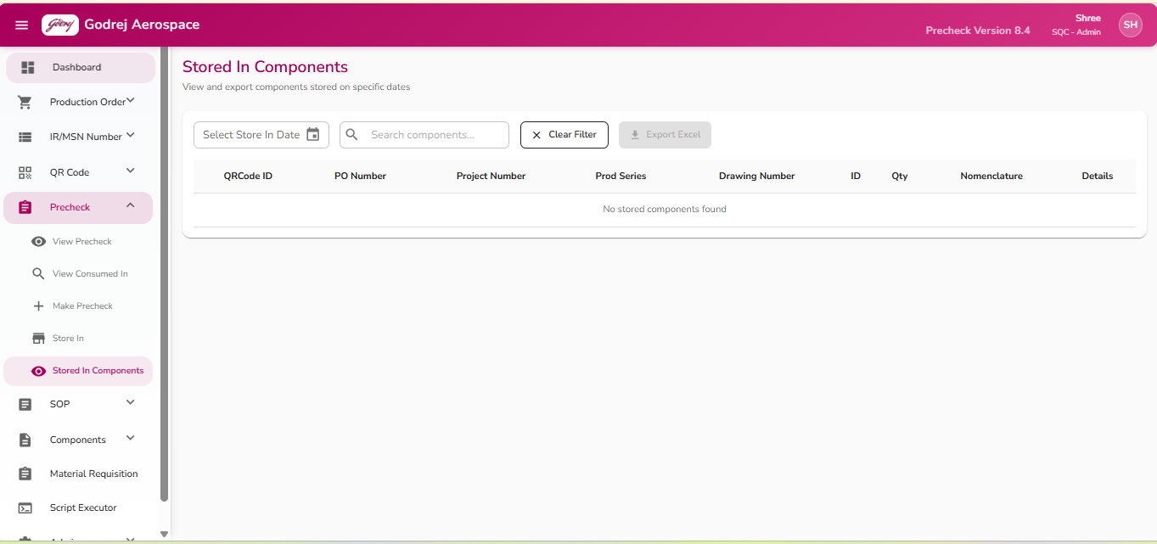
Purpose: Lets store staff look up components that were stored-in on a particular date and/or matching a particular drawing number, view their full details, and export the list to Excel.
Buttons and what they do:
- Clear Filter: Clears the selected date and the drawing number search box, and empties the results table.
- Export Excel: Downloads the currently filtered/displayed list of stored components as an Excel file. Greyed out if there are no results currently shown.
- Expand/collapse arrow (on each row, "Details" column): Shows extra information for that component — Consumed in Drawing, Status, IR Number, MSN Number, MRIR Number, Disposition, and Username.
Important notes:
- If you pick only a date, or only type a drawing number, or both, the system tells you underneath the filters how many results were found and for what date/drawing combination.
- A confirmation message (toast/snackbar) appears in the bottom-right corner after each search or export, telling you how many records were found, or if something went wrong.
- Results can be paged (5/10/25/50 rows per page) at the bottom of the table.
- If both the date and drawing-number search are left empty, the results table is cleared automatically.

Make Order
📷 Screenshot not yet provided
Please add a screenshot of the “Make Order” screen here.

Purpose: Lets a user create a new precheck order for a Production Order and Drawing Number, see the associated Bill of Materials (BOM) with available/total quantities, and then drill into a specific BOM line to see which QR-coded components are actually available to fulfil it.
Buttons and what they do:
- Make Order: Validates that all required fields are filled correctly, then submits the order. On success, a green success message appears ("Order created successfully!") and the BOM Details table below is filled in with the results (Drawing Number, Nomenclature, Available Qty, Total Qty, and ordered Qty). The button shows a spinner and is disabled while the order is being processed.
- Reset: Clears the entire form back to its defaults, and empties both the BOM Details and Available QR Codes tables.
- Double-click on a BOM Details row: Loads the list of specific QR-coded components that are available for that BOM line into the "Available QR Codes" table on the right. You must have selected a Production Series and Drawing Number first, or an error message tells you to do so.
Important notes:
- Required fields (marked with *) show a red error message underneath if left blank or invalid when you try to submit.
- The "Available QR Codes" table only populates after you double-click a row in "BOM Details" — a hint above the BOM table reminds you of this.
- Both tables support paging (5/10/25/50 rows per page).
- Success and error messages appear as banners near the top of the page and can be dismissed by clicking their close (X) icon; the success message also disappears automatically after 3 seconds.

8. SOP & BOM

View SOP
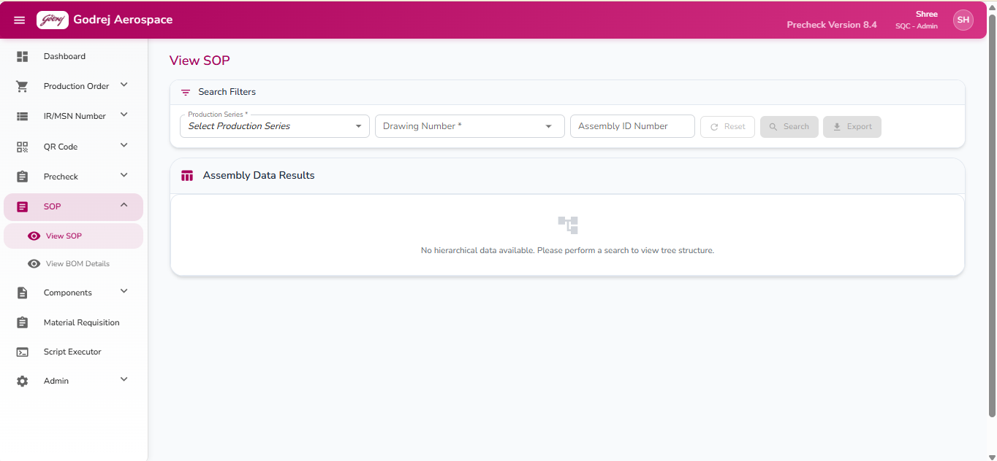
Purpose: This page lets a user look up the full structure ("tree") of an assembly for a chosen production series and drawing number — showing the assembly, its sub-assemblies, and their components in a parent-child layout — and export that data if needed.
Buttons and what they do:
- Reset: Clears the Production Series, Drawing Number, and Assembly ID Number fields along with any search results on screen. This button only becomes active once both Production Series and Drawing Number have been selected.
- Search: Looks up all matching assembly records and displays them as an expandable tree below. This button stays greyed out until both Production Series and Drawing Number are selected. If either is missing when clicked, a message lists which fields still need to be filled. After searching, a message tells the user how many records were found, or that none were found.
- Export: Downloads the currently displayed assembly data as a file. This button is greyed out until a search has returned at least one result. While the export is running, a "Exporting SOP Data" overlay with a spinner appears on the whole screen so the user cannot interact with the page until it finishes.
- Expand All (only shown once results are on screen): Opens up every branch of the tree so all sub-assemblies and components are visible at once.
- Collapse All (only shown once results are on screen): Closes all branches back down so only the top-level assemblies show.
Important notes:
- Typing fewer than 3 characters in the Drawing Number box will not show any suggestions; a hint "Type 3+ characters" is displayed instead.
- Each row in the results table shows its level in the hierarchy (top assembly, sub-assembly, component) along with Drawing Number, Nomenclature, ID Number, Quantity, Unit, IR Number, MSN Number, Remarks, Assembly Number, Build Number, and Snag Sheet Number — rows are colour/weight coded so top-level assemblies stand out from lower-level components.
- If no search has been run yet, the results area simply shows a message asking the user to search first.

View BOM Details
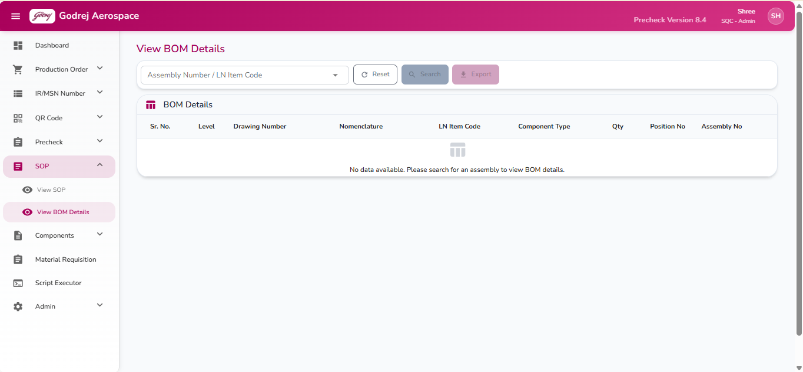
Purpose: This page shows the full Bill of Materials (list of parts and sub-parts that go into a selected assembly), letting the user drill down into each level and export the list.
Buttons and what they do:
- Reset: Clears the search box and any BOM results currently displayed.
- Search: Loads the Bill of Materials for the selected assembly. This button is disabled until an assembly has been chosen from the suggestions, and while a search is already running.
- Export: Downloads the currently displayed BOM data as a file. This button is disabled until BOM results are on screen.
- Expand/collapse arrow (shown next to each row that has sub-items): Clicking it reveals or hides that item's own child components directly underneath it, indented to show the level.
Important notes:
- Typing fewer than 3 characters in the search box shows a hint to type at least 3 characters; if nothing matches, it says no assemblies were found.
- Each result row shows Level, Drawing Number, Nomenclature, LN Item Code, Component Type, Quantity, Position Number, and the parent Assembly Number.

9. Components

Components — View Components
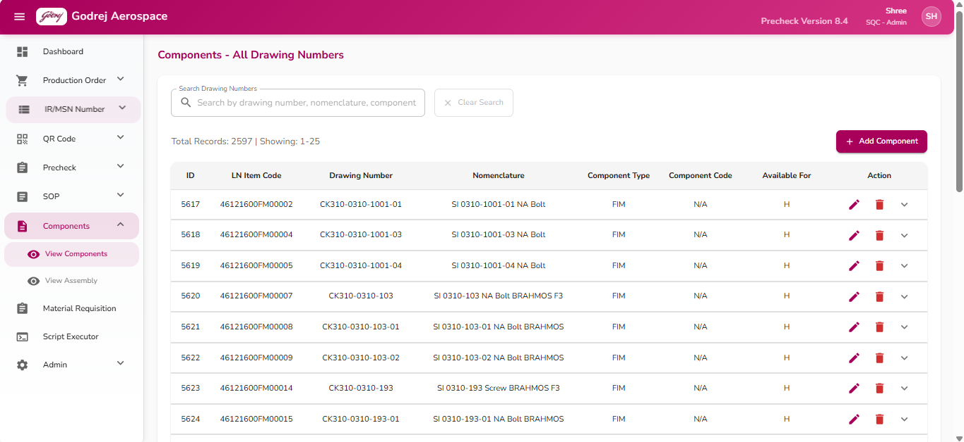

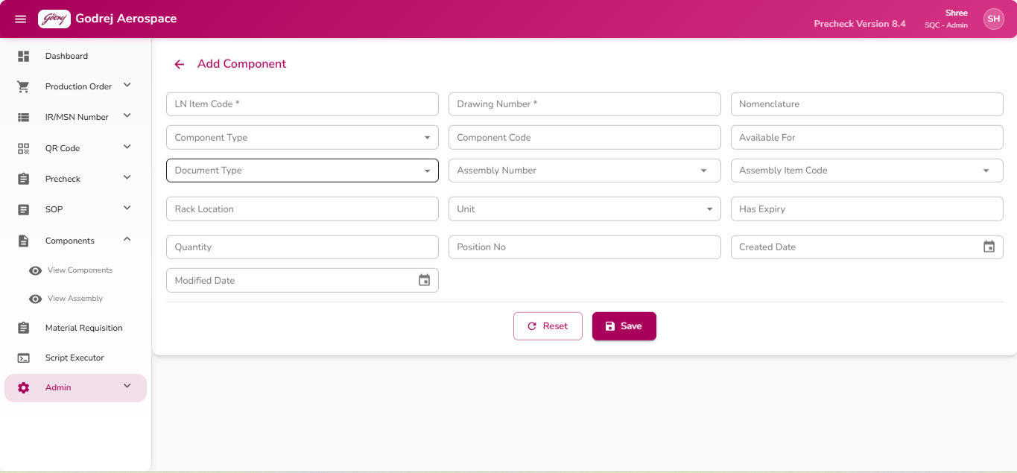
Purpose: This page lists every drawing number/component registered in the system, so QC/Store/Planner staff can search, review details, add new components, or correct/remove existing ones.
Buttons and what they do:
- Clear Search: Empties the search box and shows the full list again. This button is greyed out when the search box is already empty; when clicked, a confirmation message "Search cleared successfully" appears.
- Add Component: Opens a separate form page for entering the details of a brand-new component/drawing number.
- Edit (pencil icon, on each row): Opens a separate form page pre-filled with that component's current details so they can be corrected.
- Delete (trash icon, on each row): Opens a confirmation window asking "Are you sure you want to delete component with drawing number [X] and LN item code [Y]?" with Cancel and Delete buttons.
- Cancel: Closes the window, nothing is deleted.
- Delete: Permanently removes that component from the system, shows a success message, and refreshes the list. If the deletion fails, an error message is shown instead.
- Expand arrow (on each row): Opens an "Additional Details" panel underneath the row showing the Assembly Number, Location, whether it Has Expiry (Yes/No), Unit Name, Created Date, and Modified Date.
- Page navigation controls at the bottom (Rows per page, page numbers): Let the user choose how many components to view per page and move between pages of results.
Important notes:
- The total record count and the range currently shown (e.g., "Showing 1-25") are displayed above the table.
- If a search finds no matches, the table shows "No drawing numbers match your search criteria" instead of an empty table.

Components — View Assembly
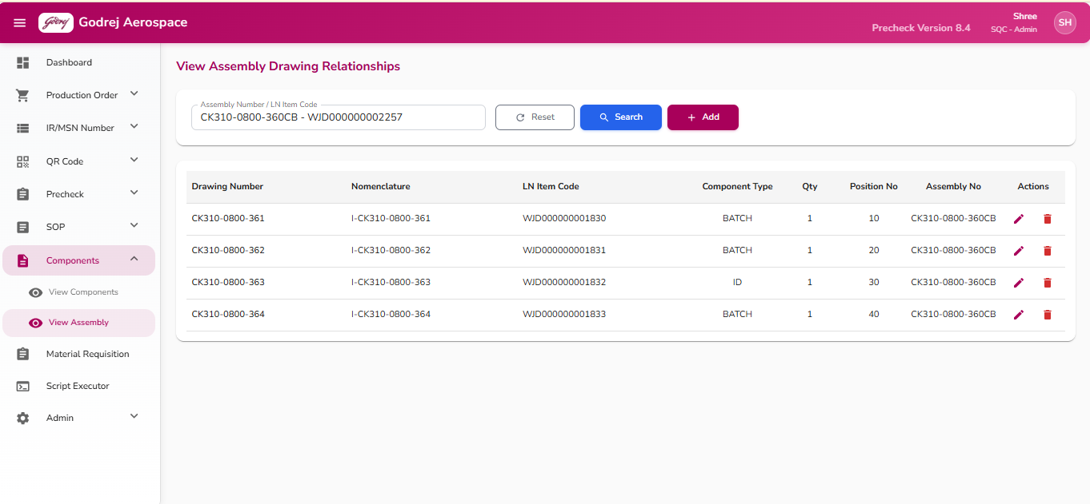

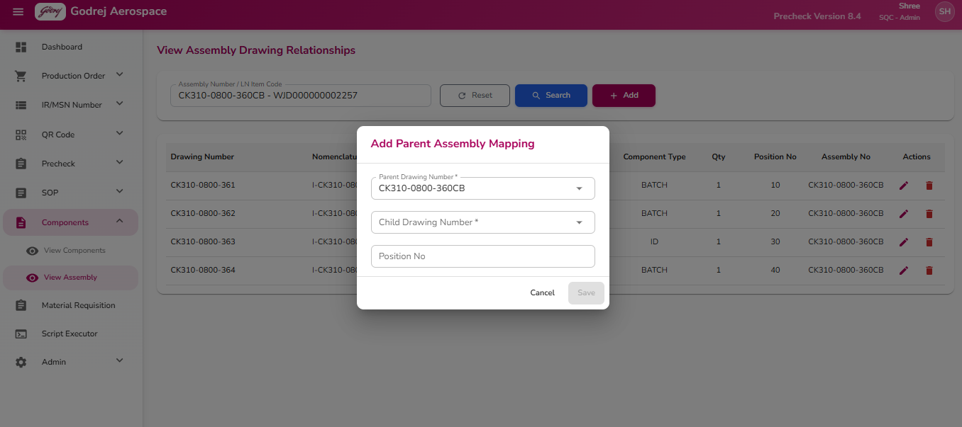

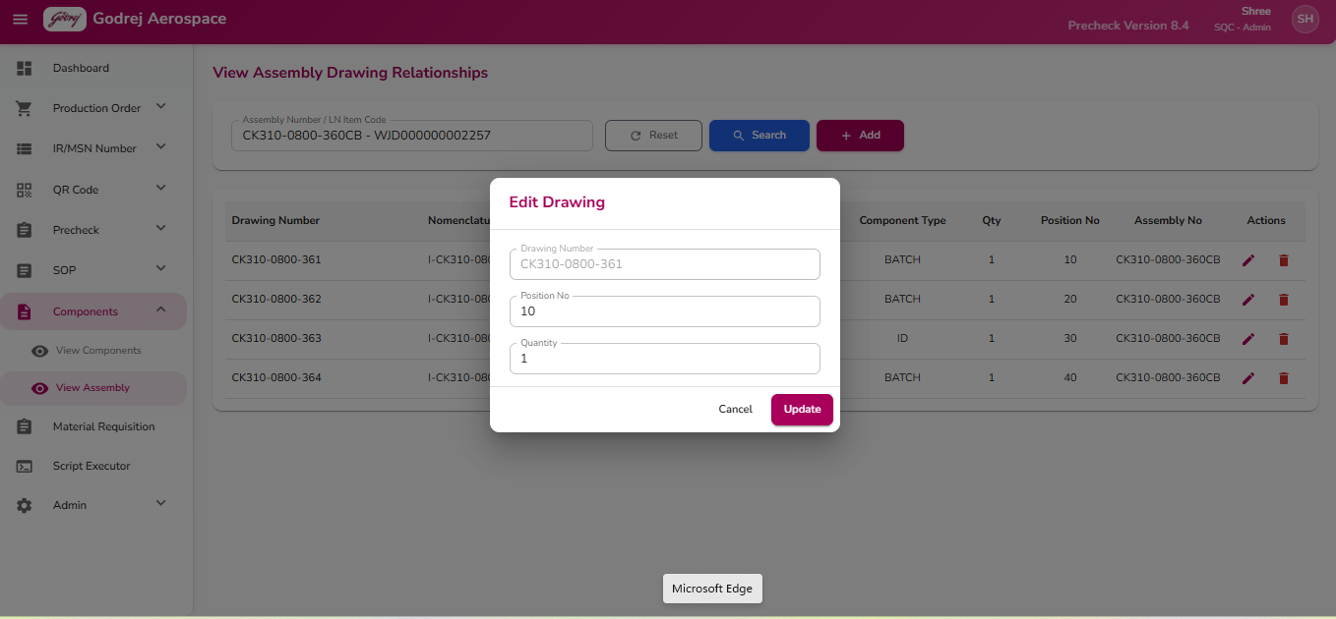
Purpose: This page is used to look up and manage the parent-child relationships between drawing numbers — i.e., which assembly a given part belongs to, in what quantity, and at what position — and to add, edit, or remove those links.
Buttons and what they do:
- Reset: Clears the search box and all search results on screen.
- Search: Looks up all parent assembly mappings for the entered drawing number or LN item code. Greyed out until something is typed. If the matched drawing number is inactive, a warning "Drawing number is not active" appears and it is left out of the results.
- Add: Opens the "Add Parent Assembly Mapping" window to link a child drawing to a parent assembly. This button only becomes active after a successful search.
- Parent Drawing Number (searchable box, required): search and select the parent assembly drawing.
- Child Drawing Number (searchable box, required): search and select the child drawing.
- Position No (text box): enter the position/find number for this part within the assembly.
- Save: Creates the new parent-child link. Greyed out until both Parent and Child Drawing Number are selected. Shows a success or failure message, then refreshes the results.
- Cancel: Closes the window without saving.
- Edit (pencil icon, on each result row): Opens the "Edit Drawing" window for that mapping.
- Drawing Number is shown but cannot be changed.
- Position No and Quantity can be updated.
- Update: Saves the changes and refreshes the results, with a success or failure message.
- Cancel: Closes the window without saving.
- Delete (trash icon, on each result row): Opens a confirmation window: "Are you sure you want to delete the parent assembly mapping [X] for child drawing [Y]?"
- Delete: Removes the link and refreshes the results, with a success or failure message.
- Cancel: Closes the window, nothing is deleted.
Important notes:
- If no matching child drawing numbers are found for a search, a message says so instead of showing an empty table.
- Search requires something to be typed in the Assembly Number / LN Item Code box — the Search button stays disabled otherwise.

Update Components
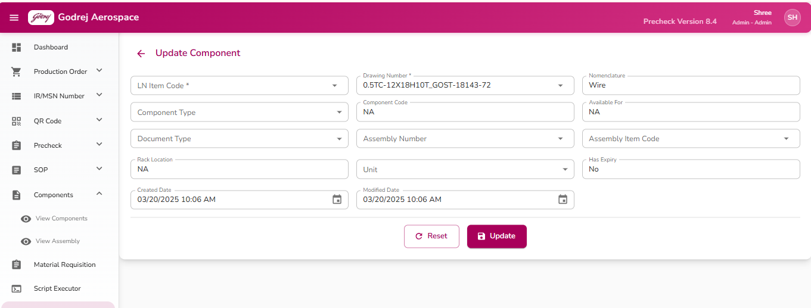
Purpose: This is a listing/search page (implemented elsewhere as the "Components" list — this page under Admin routes to the same underlying screens for adding/editing individual drawing number records). From here the Admin opens the "Add Component" or "Update Component" form to create a new drawing/component record or correct an existing one's details (item code, nomenclature, rack location, component type, assembly linkage, unit, expiry flag, quantity, etc.).
Two related forms are used for this: Insert/Update Component Mappings (the main add/edit-component form) and Update Drawing Number (a very similar add/edit form focused specifically on drawing-number-to-assembly mappings). Both forms behave the same way from the user's point of view, described below.
Buttons and what they do:
- Save (Add mode) / Update (Edit mode): Validates that LN Item Code and Drawing Number are filled in, then saves the new component or updates the existing one. While in progress, the button reads "Saving..." and is disabled. On success, a green success message appears and the Admin is automatically returned to the Components list after about 1.5 seconds. If required fields are missing, an inline error message appears under the field.
- Reset: Clears all fields back to blank (Add mode) or restores them to the original values that were loaded for editing (Edit mode). Also clears any error/success messages currently shown.
- Back arrow (top left, only shown when arriving from the components list view): Returns to the Components list without saving anything.
Important notes:
- If the Admin picks a drawing/item that already has every field filled in (item code, nomenclature, location, type, unit), and the person is NOT an Admin, the form becomes read-only automatically — this scenario mainly protects non-Admin edit access; for an Admin user this read-only lock does not apply, so Admins can always edit.
- In Edit mode, only fields that were actually changed from their original values are sent when saving — unchanged fields are left alone.
- The "Update Drawing Number" variant of this form additionally includes a Production Series dropdown (populated from Production Series entries) and always saves through a single "Save" button (no separate Update label), returning the Admin to the Assembly list after saving.

10. Material Requisition

Material Requisition
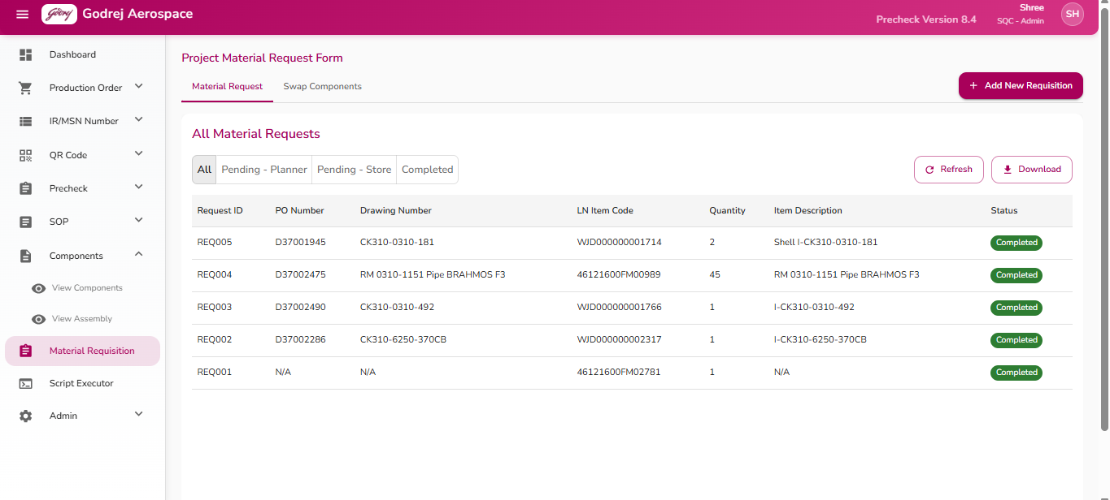

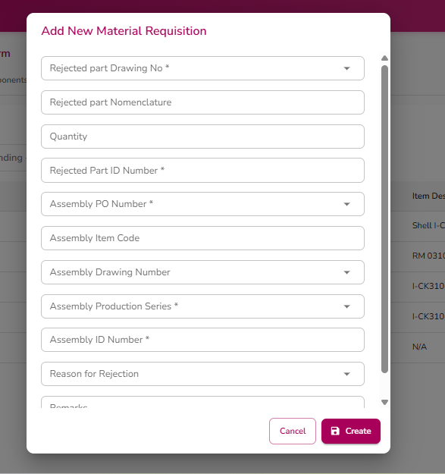

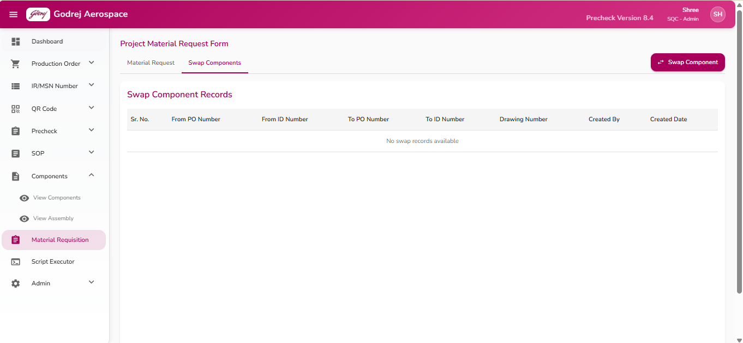

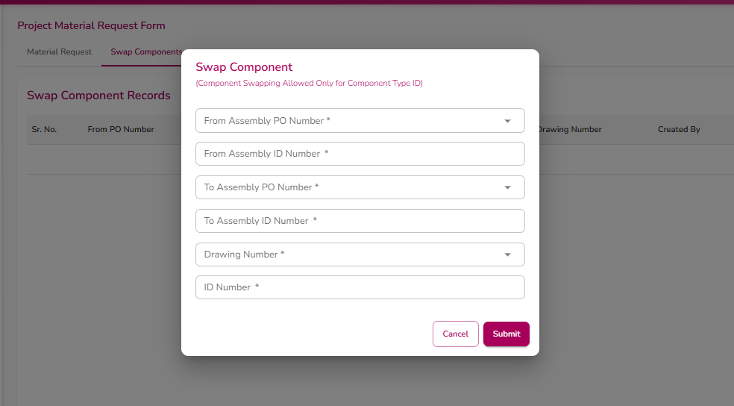
Purpose: This page is used to raise, review, and process requests for replacement/rejected material, and to record swapping of components between production orders. It has two tabs: "Material Request" and "Swap Components."
Buttons and what they do (Material Request tab):
- Add New Requisition (only visible to Planner and Admin roles): Opens the "Add New Material Requisition" window (fields listed below).
- Refresh: Reloads the request list from the system and shows "Data refreshed successfully."
- Download: Downloads the currently filtered list of requests as an Excel file. Shows a spinner while the file is being prepared.
- Clicking a table row: Opens the request details in the panel on the right for review or action.
- Submit (in the right-hand form panel): Saves the entered Remarks and moves the request forward in the workflow. This button is only enabled for Store (and Admin) users — Planner-only users cannot submit from this panel. Shows a success message, then automatically closes the panel and refreshes the list.
- Close (in the right-hand form panel): Closes the panel without saving any changes.
Buttons in the "Add New Material Requisition" window:
- Cancel: Closes the window and clears everything that was entered.
- Create: Checks that Drawing No, Production Series, Assembly ID Number, and Rejected Part ID Number are all filled in — if any are missing, a message asks the user to complete them. If all is filled in, it creates the request and shows a success message including the new request number, then closes the window.
Buttons and what they do (Swap Components tab):
- Swap Component: Opens the "Swap Component" window. A note under the title reminds the user that component swapping is only allowed for Component Type "ID."
- From Assembly PO Number (required, searchable), From Assembly ID Number (required), To Assembly PO Number (required, searchable), To Assembly ID Number (required), Drawing Number (required, searchable), ID Number (required).
- Submit: Checks all fields are filled in and that the "From" and "To" ID Numbers are valid numbers; if not, shows an error. Otherwise it records the swap, shows a success message, refreshes both the swap history table and the main request list, then closes the window automatically after a couple of seconds.
- Cancel: Closes the window and clears everything that was entered.
Important notes:
- Which fields and buttons a user can act on depends on their role: Planner/Admin can create new requisitions; Store/Admin can fill in store details and submit a request forward.
- Success and error messages appear as banners at the top of the relevant tab or dialog and can be dismissed by clicking the close (x) on them.

11. Script Executor

Script Executor
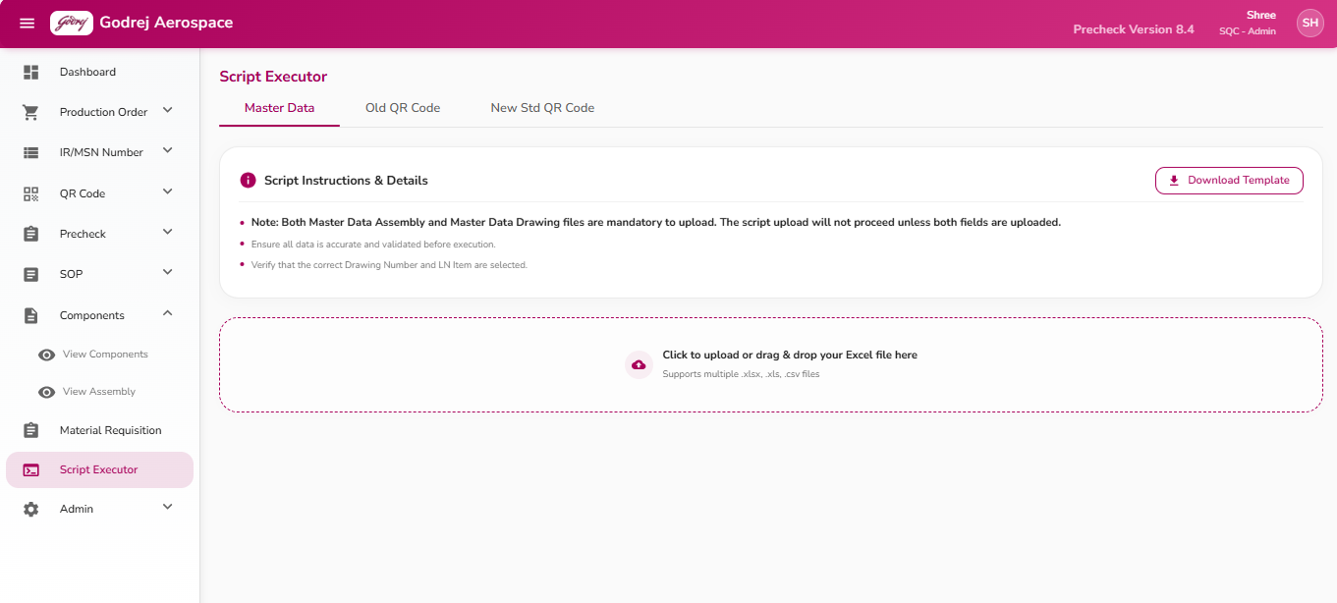

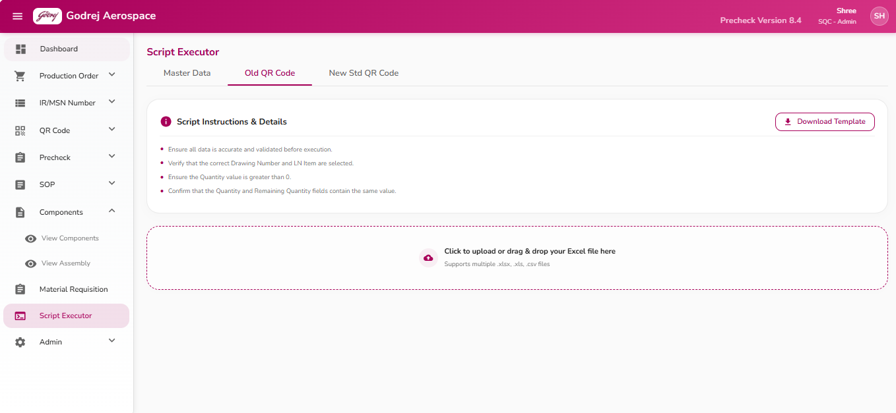

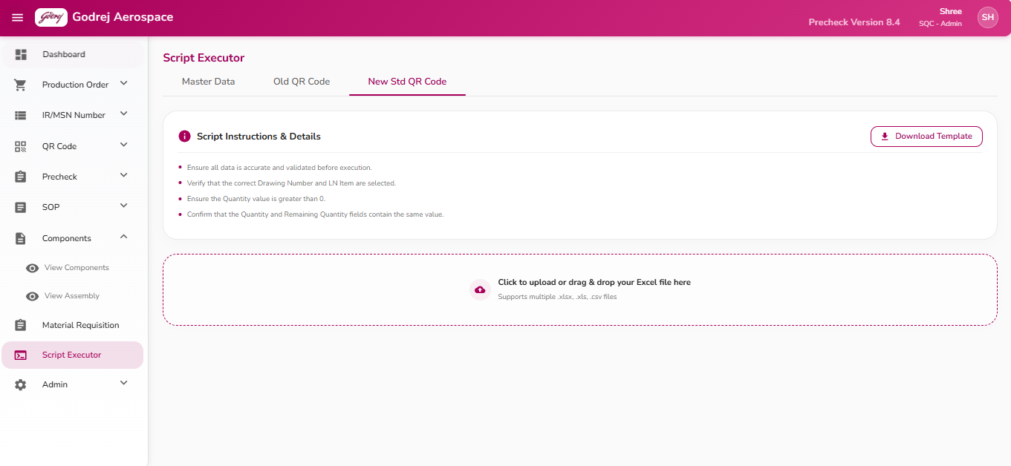
Purpose: This page is used to bulk-load foundational data into the system by uploading specially formatted Excel files - Master Data (Drawings and Assemblies), Old QR Code data, or New Standard QR Code data - and then running the corresponding processing script to commit that data into the system.
Buttons and what they do:
- Download Template: Downloads a blank Excel template matching the currently selected tab, so you know the correct column layout to use. On the Master Data tab, since two different templates are needed (Assembly and Drawing), clicking this shows a small menu to pick which one to download; on the other tabs it downloads directly.
- X icon on a selected file: Removes that file from the list before it has been uploaded to the server (only available before you click Confirm & Upload).
- Confirm & Upload: Sends the selected file(s) to the server for storage and verification. This button is disabled if any file failed its format check, or while an upload is already in progress (label changes to "Uploading..."). For the Master Data tab, this also checks that every LN Item Code used in the Assembly file also appears in the Drawing file (and vice versa) - if any codes don't match up, a popup lists the mismatched codes and the upload is stopped so you can fix the files first.
- Execute Script: Appears only after files have been successfully uploaded to the server. Running this actually commits the uploaded data into the system's database. While running, the button shows "Executing...". Disabled if a file turns out to be invalid.
- Cancel: Clears all selected files, previews, and upload progress on the current tab, letting you start over.
- Done (in the results popup): Closes the results summary popup after a script has finished running, and shows a final success/warning/error notification message at the bottom of the screen.
- Okay (in the Missing Required File popup): Appears only on the Master Data tab if you try to upload without both the Assembly and Drawing files present. Clicking Okay closes the popup and reopens the file picker so you can add the missing file.
- Okay (in the LN Item Code Mismatch popup): Simply closes the mismatch details popup so you can go fix the files.
- Okay (in the Wrong File Uploaded popup): Appears if the file you uploaded doesn't match the expected template for the selected tab (e.g., you picked a QR Code file while on the Master Data tab). Closes the popup so you can select the correct file.
- Copy Log (in the Script Execution Failed popup): Copies the on-screen error/output text to your clipboard, so it can be pasted elsewhere (for example, to share with technical support). The button label briefly changes to "Copied" as confirmation.
- Close (in the Script Execution Failed popup): Dismisses the error details popup.
Important notes:
- For the Master Data tab specifically, both the "Master Data Assembly" and "Master Data Drawing" files must be uploaded together - the system will not proceed with just one.
- Files are checked against the expected template for whichever tab is active; uploading the wrong type of file (e.g., a QR Code file on the Master Data tab) is rejected with an explanation of what was expected versus what was detected.
- After a script runs successfully, a results summary shows counts such as total records processed, how many succeeded, warnings, and errors - along with a detailed text output/log if the server provided one.
- If the script execution fails outright, a separate red-themed error popup appears showing a "Validation Report" and, if available, a "Developer Stacktrace" tab with the raw technical error - this is mainly useful when reporting the issue to a technical support/development team.
- After a script finishes executing successfully, the uploaded files and their previews are cleared automatically, so the screen is ready for a fresh upload.

12. Admin
The pages in this section are only visible to users with the Admin role.

Archive
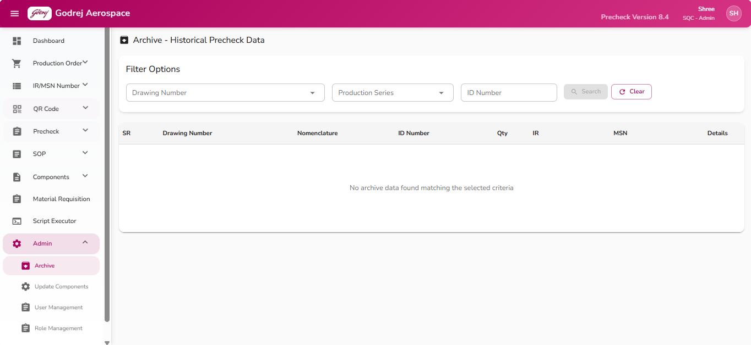
Purpose: This page lets an Admin look up historical (older/consumed) precheck records for a component — essentially a search/reporting screen to trace what happened to a given drawing/part in the past, rather than a page for entering new data.
Buttons and what they do:
- Search: Looks up archive records matching the Drawing Number, Production Series, and ID Number entered. This button stays greyed out (disabled) until all three fields above have a value — the search cannot run with any of them empty. Once clicked, the matching records appear in the table below.
- Clear: Empties all three search fields and clears the results table, so the Admin can start a fresh search.
- Expand/Collapse arrow (per row, under "Details"): Click to expand a row and reveal extra information for that record — Remarks, the User who created it, and the Date it was created. Click again to collapse it back.
- Column header click (e.g. "Drawing Number", "Nomenclature", "ID Number", "IR", "MSN"): Clicking a sortable column header sorts the table by that column; clicking it again reverses the sort order (ascending/descending).
- Pagination controls (bottom of table): Lets the Admin move between pages of results and change how many rows are shown per page (5, 10, 25, or 50).
Important notes:
- No data loads automatically when the page opens — the table stays empty until a Search is performed with all three fields filled in.
- If no records match the search, the table displays "No archive data found matching the selected criteria."

User Management
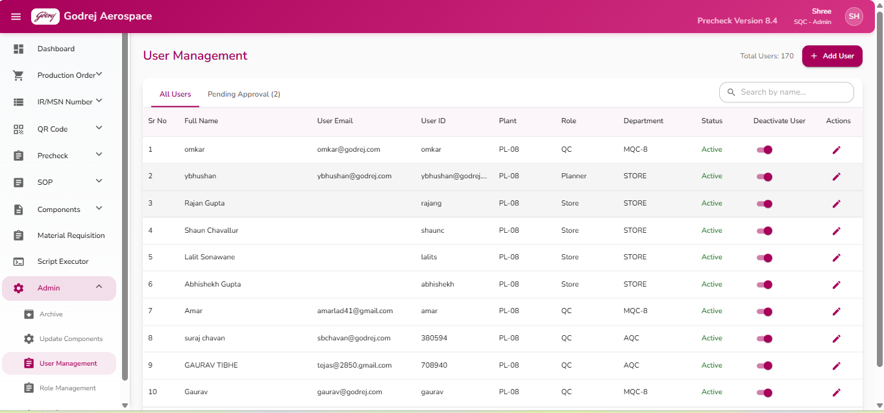

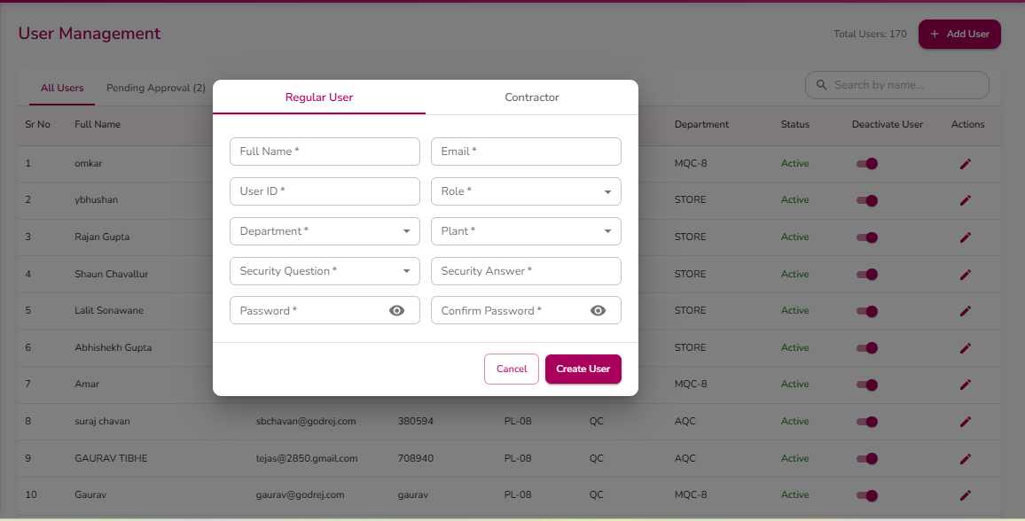

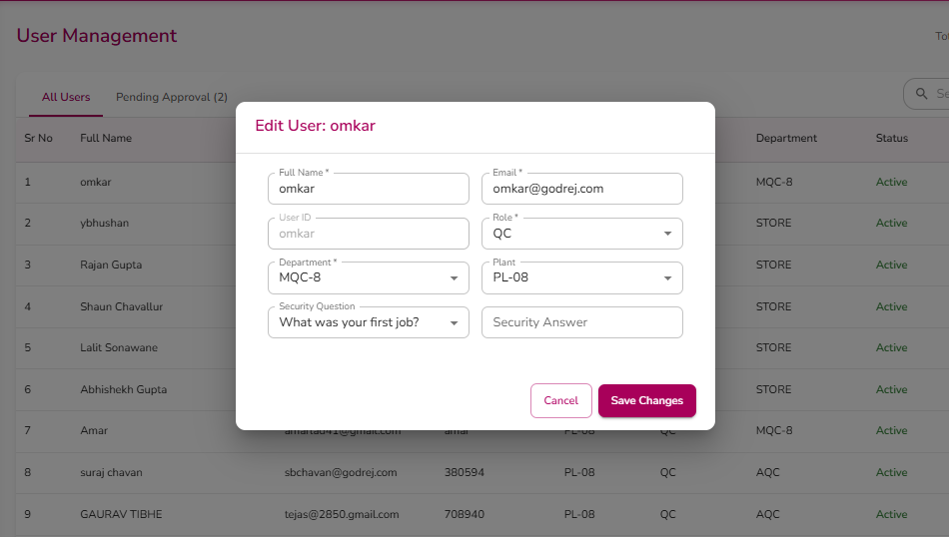
Purpose: Lets the Admin create new user accounts (both regular staff and contractor accounts), edit existing users' details, approve new self-registered users, and activate/deactivate accounts.
The page has two tabs at the top: All Users and Pending Approval (n) (the number shows how many new sign-ups are waiting for approval). A search box lets the Admin filter the visible list by name.
Buttons and what they do:
- Add User (top right, visible only to Admin): Opens the Add User popup, defaulting to the "Regular User" tab.
- Regular User / Contractor tabs (inside the Add User popup): Switches which set of fields is shown, since contractors need fewer details than regular staff.
- Show/Hide password icons (eye icon) on Password and Confirm Password fields: Toggles whether the typed password is shown in plain text or masked as dots.
- Create User (inside Add User popup): Validates the form, then creates the account.
- For a Regular User: all listed fields are required; email must be in a valid email format; password must be at least 6 characters; Password and Confirm Password must match. If any check fails, an error message appears and nothing is saved.
- For a Contractor: Full Name, User ID, Password, Role, and Department are required.
- On success, a confirmation message appears and the popup closes.
- Cancel (inside Add/Edit popup): Closes the popup without saving.
- Edit icon (pencil) on a user's row (Actions column): Opens the Edit User popup pre-filled with that user's details. Only enabled for Admins, and only for users whose account is currently Active — editing an inactive user is blocked (with a tooltip explaining why).
- Save Changes (inside Edit User popup): Saves the updated details for that user and closes the popup, showing a success message.
- Deactivate/Activate toggle switch (in the "Deactivate User" column of the table): Turning this switch on/off opens a confirmation popup asking "Are you sure you want to activate/deactivate the user account for [name]?" This switch — and the whole toggle column — is disabled (greyed out) for non-Admins, and an Admin cannot toggle their own account (a tooltip explains "You cannot deactivate your own account").
- Activate / Deactivate (inside the confirmation popup): Confirms the change — turns the user's account on or off. Deactivating prevents that person from logging in or using the app at all until reactivated. While processing, the button shows "Processing..."
- Cancel (inside the confirmation popup): Closes the popup without changing the user's active status.
- Approve button (Pending Approval tab only, in the "Approve User" column): Approves a self-registered user, turning their pending signup into a full active account. Only enabled for Admins (a tooltip explains "Only administrators can approve users" for non-Admins).
Important notes:
- The "Status" column shows Active (green) or Inactive (red) text for existing users, and "Pending Approval" (orange) for users awaiting approval.
- The "Admin" role and "Admin" department are deliberately excluded from the Role/Department dropdown choices when adding a new Regular User — new users cannot be created directly as Admins through this form.
- All the account-changing actions on this page (add, edit, activate/deactivate, approve) require the current logged-in user to have the Admin role — buttons are visibly disabled with an explanatory tooltip for any other role, in the rare case a non-Admin somehow reaches this page.

Role Management
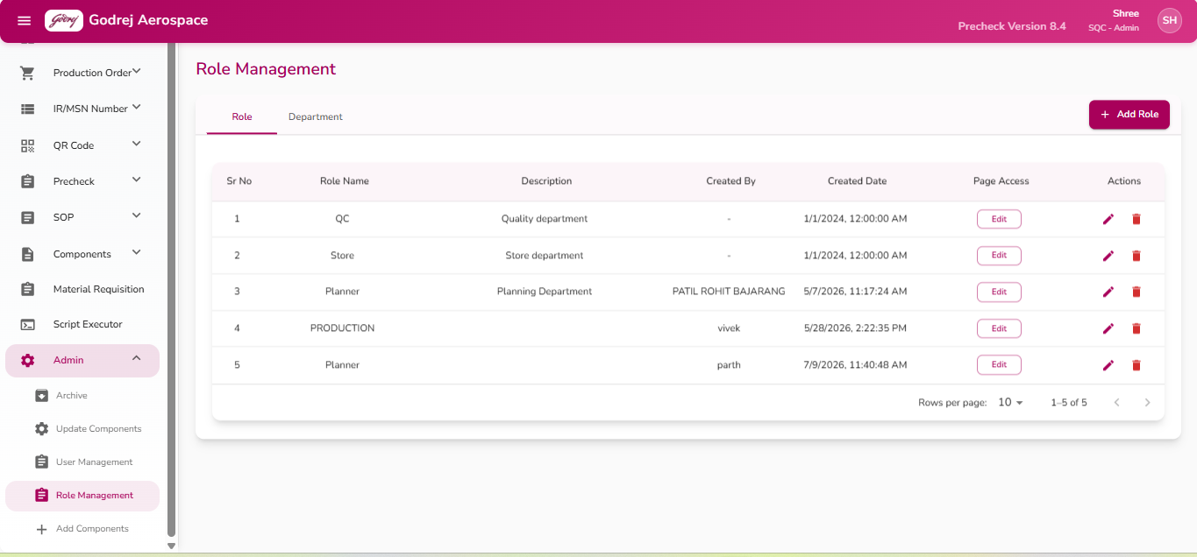

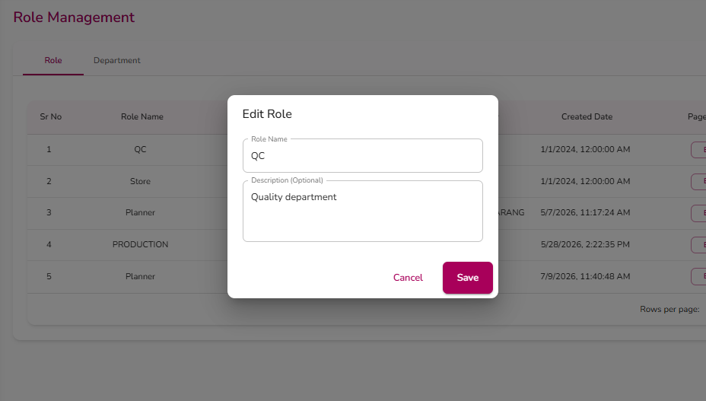

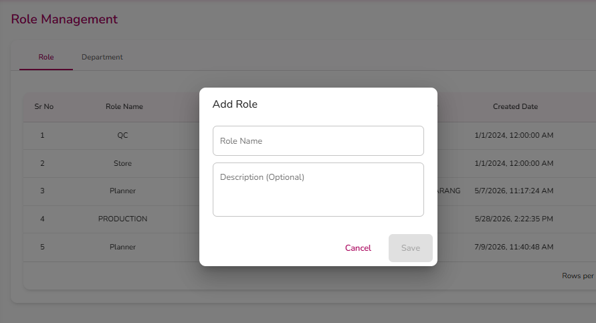

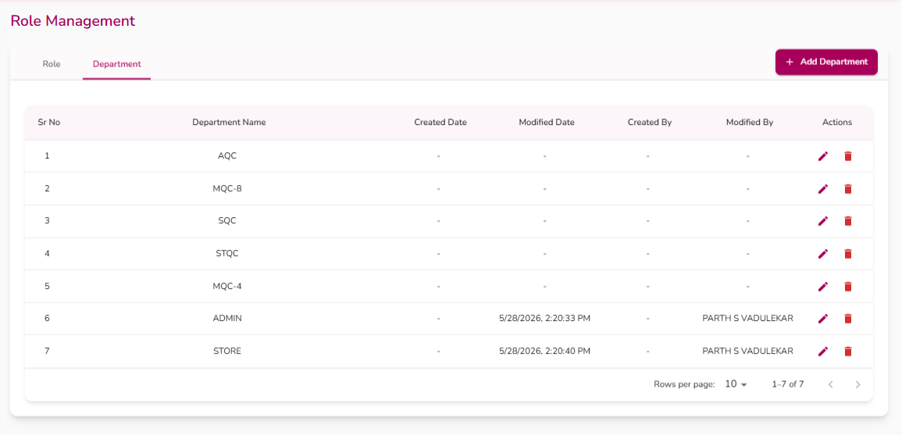

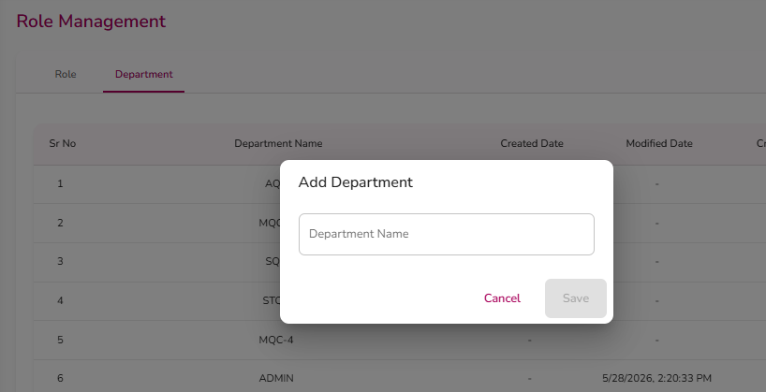

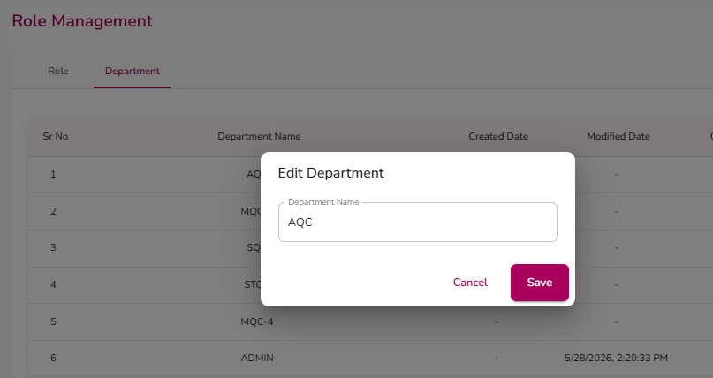
Purpose: Lets the Admin define what roles exist in the system (Admin, QC, Store, Planner, or any new custom role) and what departments exist, and — critically — control exactly which pages each role is allowed to see and use throughout the app.
This page has two tabs: Role and Department. Both list existing entries in a table with Add/Edit/Delete controls, similar in style to the Add Components page.
Buttons and what they do:
- Add Role / Add Department (top right, label changes with the active tab): Opens a popup to create a new role or department.
- Save (in the Add/Edit Role or Department popup): Saves the new entry or the changes to an existing one, then closes the popup and shows a success message. Disabled until the Role Name / Department Name field has text.
- Cancel (in the popup): Closes without saving.
- Edit icon (pencil) on a row: Opens the popup pre-filled with that role's or department's current details for editing. On the Role tab, this icon is disabled (greyed out, with a tooltip "Inactive - cannot edit") if the role has been deactivated.
- Delete icon (trash can) on a row: Same two-step confirm pattern as elsewhere — clicking it swaps to a check mark (confirm) and an X (cancel); clicking the check mark permanently deletes the role/department. Also disabled for inactive roles.
- Page Access "Edit" button (Role tab only, in the "Page Access" column — this column and button only appear when the person viewing the page is logged in as Admin): Opens the Manage Page Access popup for that specific role, described below. This button is disabled for roles that are inactive.
Important notes — how the permissions/page-access system works:
- Every role (QC, Store, Planner, or any custom role the Admin creates) has its own independent list of pages it is allowed to access. The Admin manages this per-role, not per-individual-user.
- Clicking a role's Page Access "Edit" button opens the Manage Page Access dialog. It shows a tree/list of every page in the app for that role, with the page name on the left and two selectable options on the right: an "Edit" (pencil icon) column and a "Block" (circle-slash icon) column, each with a radio button.
- For each page, the Admin picks exactly one of two settings:
- Full Access (radio button under the pencil/Edit icon) — the role can fully open and use that page.
- No Access (radio button under the block icon) — the role cannot access that page at all.
- There is no separate "view-only/read-only" option in this list — access is simply full or none, one radio button per page, per role.
- Pages that have sub-pages show an arrow to expand/collapse the list of child pages underneath the parent page.
- Cascading rule: If the Admin sets a parent page's access to Full Access or No Access, every child page underneath it is automatically set to match. For example, marking "Admin" as No Access will also mark "Archive," "Update Components," etc. underneath it as No Access at the same time.
- Update Access button: Saves only the pages whose access setting was actually changed since the dialog was opened (unchanged pages are not resent). If nothing was changed, clicking it simply closes the dialog with no update sent. While saving, the button shows "Updating..."
- Cancel button: Closes the dialog and discards any unsaved changes made in this session.
- Any change made here takes effect for every user assigned to that role — it is not per individual user.

Manage Page Access (popup within Role Management)
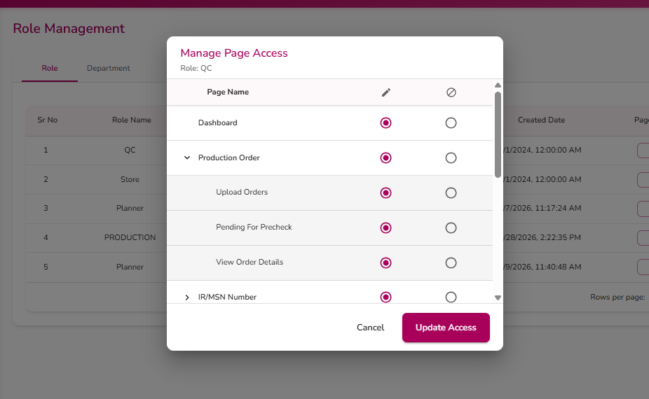
This is not a separate page but the permissions dialog opened from Role Management's Page Access "Edit" button — documented in detail under Role Management above, since that is the only place it is reached from and it directly controls what QC, Store, and Planner (and any other role) can see elsewhere in the Precheck app.

Add Components
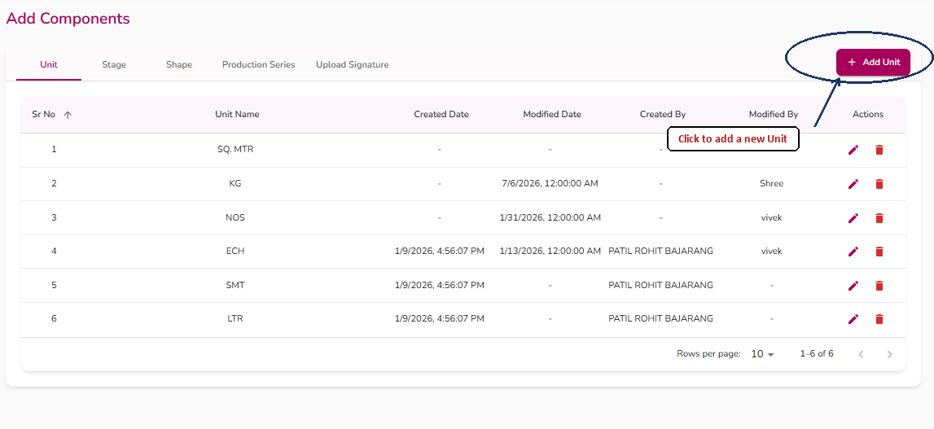

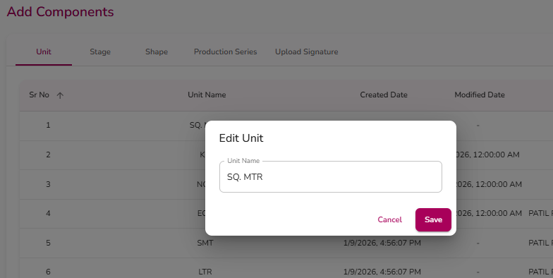

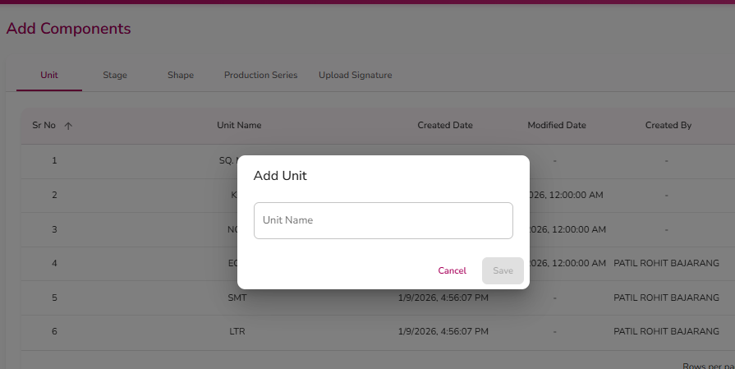

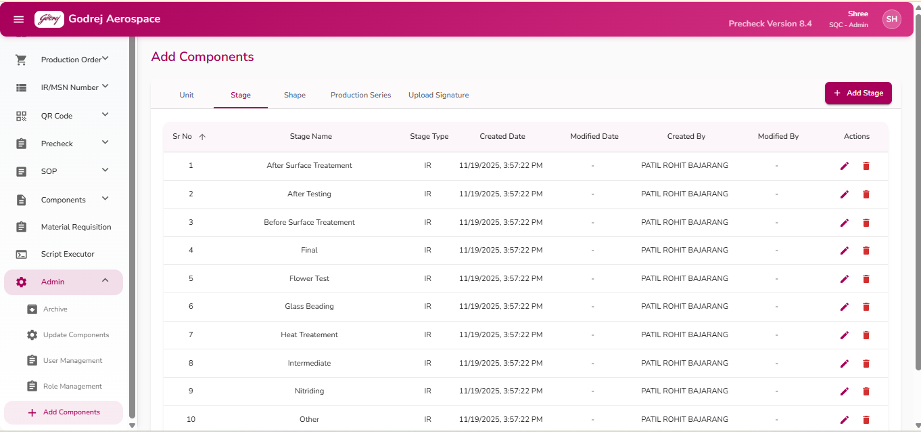

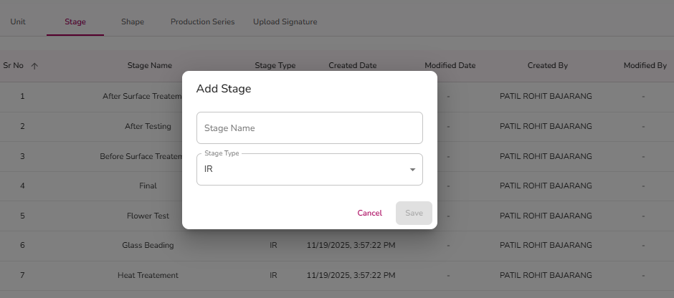

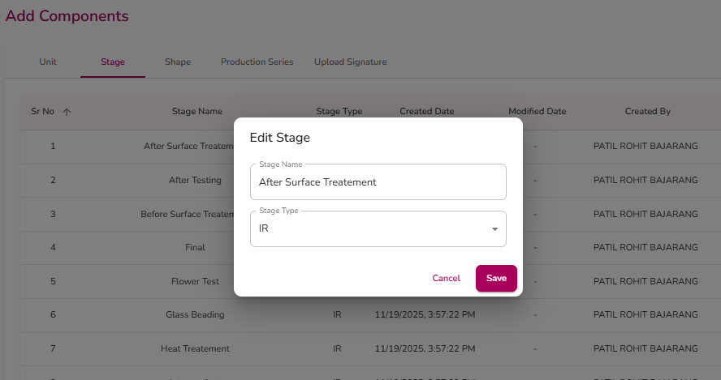

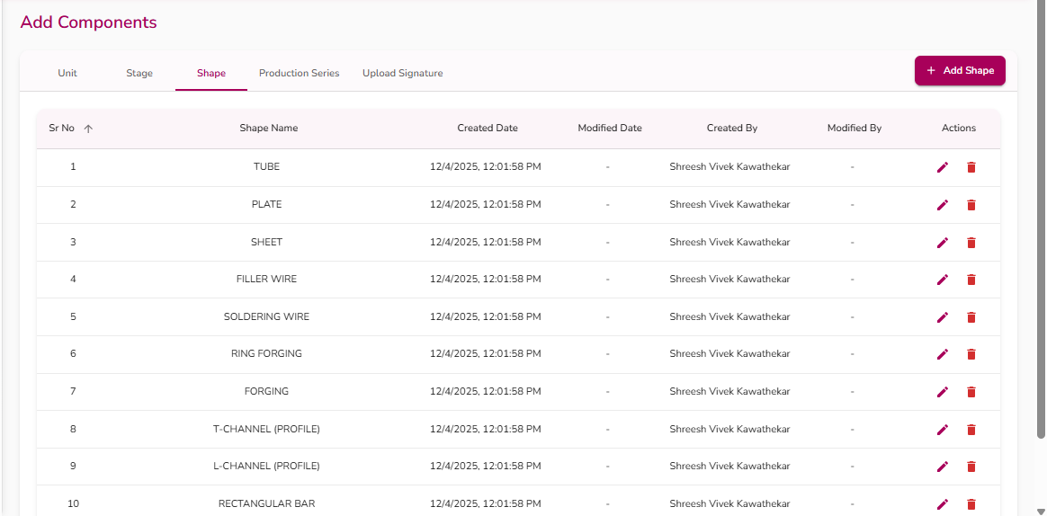

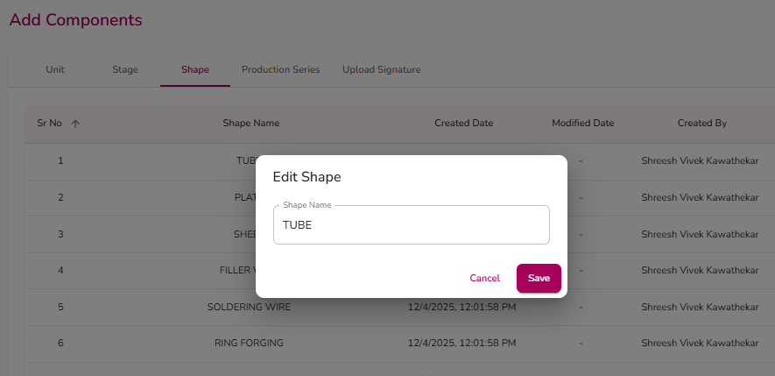

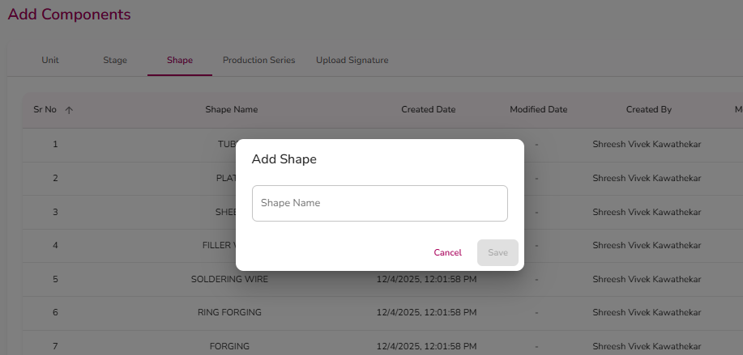

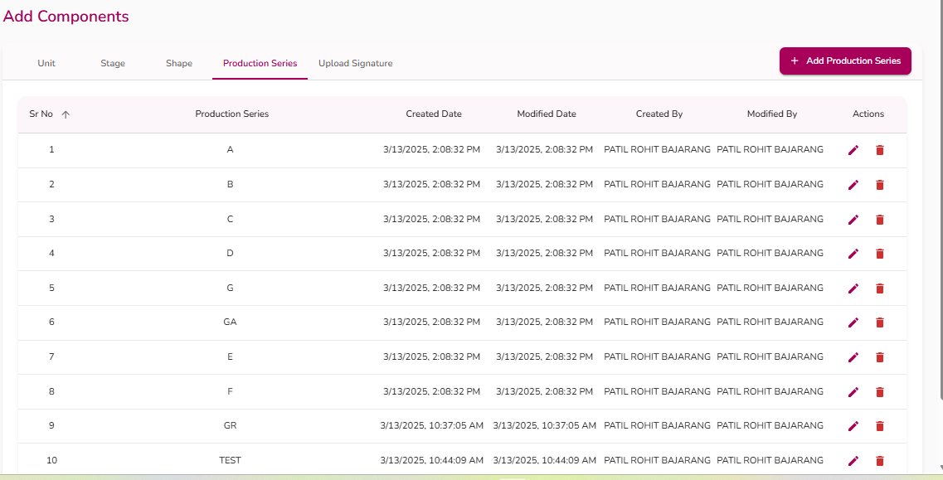

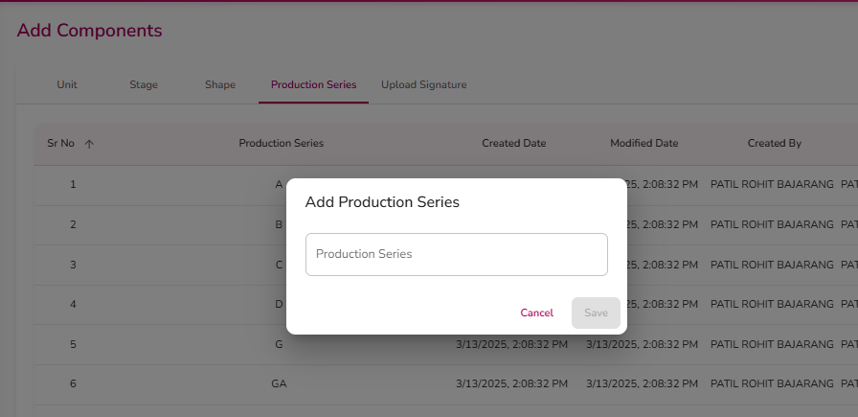

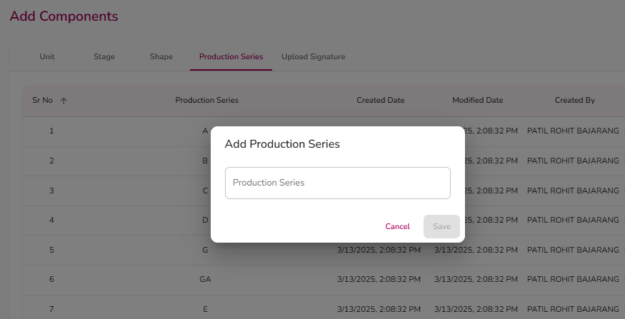

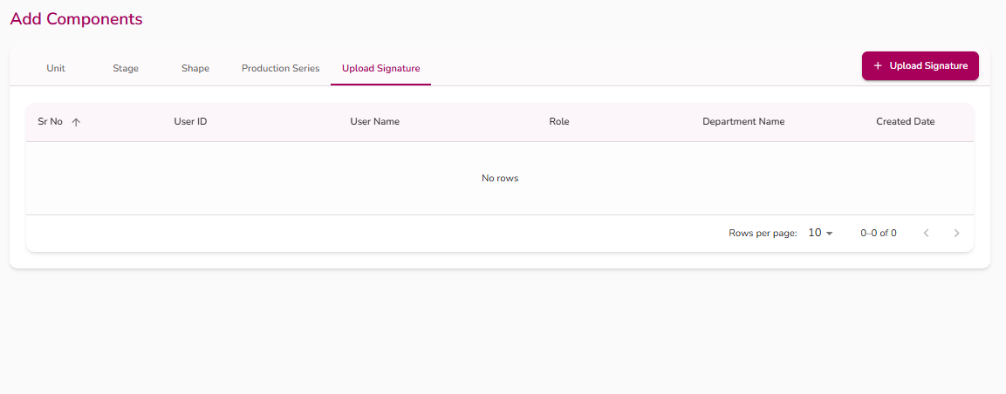

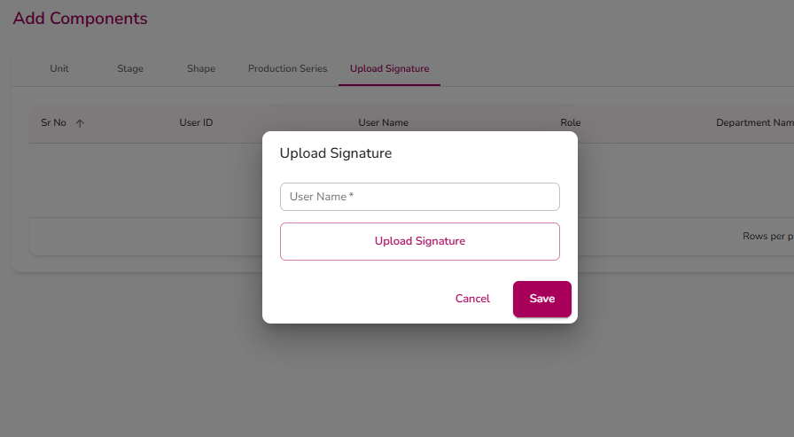
Purpose: This page lets an Admin set up the basic "building block" values used everywhere else in the app — Units, Stages, Shapes, Production Series, and staff signatures. These values then appear as dropdown choices on other forms (for example, when adding a drawing or filling in a precheck form).
This page is organized into five tabs: Unit, Stage, Shape, Production Series, and Upload Signature. Each tab (except Upload Signature) shows a table of existing entries and works the same way: an "Add" button opens a small popup to create a new entry, and each row has Edit and Delete icons.
Buttons and what they do:
- Add [Unit/Stage/Shape/Production Series] / "Upload Signature" (top right of the tab bar): Opens a popup form for the tab currently selected. The button label changes depending on which tab is open.
- Save (inside the Add/Edit popup): Saves the new entry, or updates the entry being edited, and closes the popup. The button is disabled until the Name field has text in it. While saving, the button shows "Saving…" and is temporarily disabled. On success, a green confirmation message briefly appears at the top of the screen; on failure, an error message appears inside the popup.
- Cancel (inside the Add/Edit popup): Closes the popup without saving any changes.
- Edit icon (pencil) on a table row: Opens the same popup pre-filled with that row's existing values, so the Admin can change the name (and, for Stage, the Stage Type).
- Delete icon (trash can) on a table row: Does not delete immediately. It first swaps the row's icons to a Confirm (check mark) and Cancel (X) icon.
- Clicking the check mark confirms and permanently removes the entry (a confirmation message appears at the top).
- Clicking the X cancels the delete and restores the normal Edit/Delete icons.
- Upload Signature button (inside the file picker area of the Upload Signature popup): Opens the device's file browser so the Admin can choose a signature image (any image file) to attach to the selected user. The chosen file's name is shown next to the button once selected.
Important notes:
- On the Upload Signature tab, clicking Save without picking a user, or without picking an image file, shows an error message and does not submit.
- Only entries marked "active" are shown in these tables; inactive/deleted entries are hidden from the list (there is no way on this page to see or restore deleted entries — see the Archive page instead for historical records).
- The "Created By" / "Modified By" / "Created Date" / "Modified Date" columns are read-only, automatically filled in by the system, showing which user made the entry and when.

